North Carolina Animal Emergency Response Working Group Manual for Large Animal Emergencies
Last revised 3/26/2024

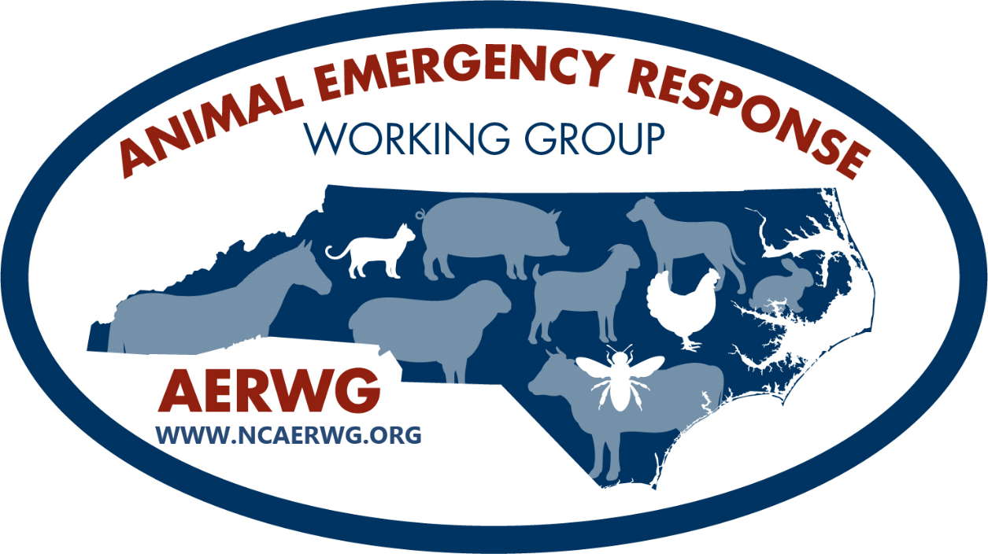

Disclaimer: This manual is for awareness only on animal emergency responses and the components that go into it. It will NOT teach Technical Large Animal Emergency Response techniques nor create subject matter experts within that field. If seeking additional training in large animal emergency response, please monitor NC TERMS for courses or contact some of the organizations listed in the appendices.
***For the greater purpose of this manual the term LIVESTOCK is to include domestic animals that provide meat, fiber, milk, or food products (ex. eggs) including, but not limited to cattle, sheep, swine, horses, goats, poultry, llamas, alpacas, bees, and specialty animals. ***

This guide was created through the cooperative efforts of the NC Animal Emergency Response Working Group (AERWG). The AERWG is a collaborative effort of many state and local partners who are dedicated to enhancing the preparedness and response capabilities for any incident involving animals, including but not limited to livestock, throughout the state with coordination from many sectors. The working group was established to assist with awareness of animal-related incidents; resource identification; communication/notifications of incidents at the local, regional, and state level; and to train response personnel and any interested parties starting at the county level. Priorities of this mission are responder and public safety; humane and timely assistance of animals in an emergency; establishing animal sheltering capabilities; ensuring appropriate trainings are available; and conducting public outreach. The areas of focus are in solidifying notification processes; scene arrival and assessment; containment and security of the scene; triage, extraction, and relocation of animals; mortality management; humane depopulation, if deemed necessary; and debriefing.

Introduction
There are many reasons why animals should be included in planning and training efforts. Some of the main ones will be listed below.
- Protection of Public Safety: There is a high societal value attached to many animals, not just companion animals, due to a very strong human-animal bond. Through their actions or inactions, humans will risk themselves to save an animal. Not only are they putting themselves at risk, but responders and other members of the public can also be endangered directly or through diversion of critical response resources. This was evident during Hurricane Katrina when 50% of people who refused to evacuate did so because they could not take their pets. An amendment to the Stafford Act, called the Pets Evacuation and Transportation Standards (PETS) Act was passed to address transportation and sheltering for companion animals during disasters. However, the PETS Act only addresses companion animals, and many livestock owners will also put themselves at risk to protect their animals.
- Protection of Public Health:
  - Mental Health: During any incident, not just large-scale disasters, survivors and responders are under tremendous physical and mental stress. Loss of pets or other animals can be a serious source of grief and anxiety and survival of animals may positively support the mental health of both groups. There are some great resources available for those experiencing a mental health crisis as it relates to first responders or those working in agriculture. Some of the available resources are listed in Appendix J.
  - General Health: When animals are stressed, they are more likely to shed pathogens that can cause illness in humans. Another potential source of human disease can be from animal carcasses that can contaminate the environment including drinking water when not probably disposed of. Planning and responding appropriately to incidents involving animals can help mitigate some of these risks. Some examples include pet and livestock sheltering options, appropriate animal decontamination, biosecurity practices and PPE, mortality management, and messaging to the public concerning the risks.
- Economics - Agriculture and agribusiness is North Carolina’s number one industry and livestock continue to play a major role in keeping it in that top spot. Farm cash receipts from 2020 totaled over $10 billion with 66.0% of that being from livestock, dairy, and poultry. On any given day, there are roughly 810,000 cattle, 9.4 million hogs, 29,000 sheep, 55,000 goats, 971 million chickens, and 30 million turkeys in NC. The horse industry also contributes an estimated $2 billion annually with more than 306,000 horses statewide. Many of these animals will be transported to sales/markets, grower or finisher operations, processing facilities, shows/exhibitions or for entertainment purposes such as trail rides. With such large numbers of animals and many in transit, it is not a question of if an incident involving animals will occur but when.
- Service and Working Animals: Americans with Disabilities Act (ADA) provides special protections for people with service animals. Both ADA and Stafford Act includes mandates regarding service animals. Another category of animals that receive special protections are emergency response or working animals. These animals provide essential services to military, law enforcement, and emergency response organizations and should be provided the highest level of care.
Since animal responses are low frequency, historically there have been limited trainings available for first responders in NC. However, even though these incidents do not occur often, they are very high-risk to not only the animals, but the people involved in the response which is why planning and training is so important. Another challenging aspect of animal response is that they can occur at any time and in any place. An incident can involve a single animal or hundreds. Those animals can weigh a couple of pounds or several thousand. Incidents can occur in a barnyard, stable, stockyard, in or near a major road, in the middle of nowhere with limited access, or any location in-between. They can be the sole cause of the emergency or be part of a much larger disaster with many other working parts. Animals can be victims of natural and manmade disasters just like humans, and when preparing for the human side, animals should also be incorporated into the planning process. As with any response, human life safety missions are always first priority.
For the purpose of this manual and the associated training, we will focus mainly on livestock species, but all rescue/response principles cross over to other species whether they are companion animals, wildlife, or exotics.
** It is easier to explain why you need a plan, than why you didn’t have one!**

National Incident Management System and the Incident Command System
All responders, whether they are paid or volunteer, should have a basic understanding of the National Incident Management System (NIMS) and the Incident Command System (ICS). Knowledge and utilization of ICS and its components will create a more organized, efficient, safe, and successful outcome for all responders and animals regardless of the size and scope of the incident.
- National Incident Management System (NIMS)
  - 2001 terrorist attacks highlighted the need for an integrated nationwide incident management system with standard structures, terminology, processes, and resources
  - Provides a systematic, proactive approach to guide departments and agencies at all levels of government, nongovernmental organizations, and the private sector to work seamlessly to prevent, protect against, respond to, recover from, and mitigate the effects of incidents, regardless of cause, size, location, or complexity
- The Incident Command System (ICS)
  - A component of NIMS
  - Standardized approach to the command, control, and coordination of emergency response
  - Provides a common hierarchy within which responders from multiple agencies can be effective
    - Standard terminology
    - Modular, flexible, and adaptable
      - Adjusts to incident size and complexity
    - Efficient and effective management across and between organizations, sites, and jurisdictions
    - All-hazards approach
- ICS Structure
- Top-down structure
      - Not all positions need to be staffed for all incidents - dependent on the size and complexity of the response
- Command Staff
      - Incident Commander (IC): overall responsibility for the incident and sets incident objectives
        - Only position that is always staffed
      - Safety Officer: monitors conditions, practices, and procedures to ensure they are safe for responders and the public
        - Allowed to stop any activity due to safety concerns
      - Liaison Officer: primary contact for supporting agencies
      - Public Information Officer (PIO): provides information to stakeholders
        - If media is involved, this position should be filled by someone who is tactful and knowledgeable
          - Media will find someone to talk to so provide someone you can trust to fill this role
- General Staff
- Operations Section performs operations to meet incident goals, develops tactical assignments and organization, and directs all tactical resources
        - Where the bulk of the response efforts occur
- Planning Section collects, evaluates, and disseminates information pertaining to the incident; maintains status of resources; and prepares and documents the Incident Action Plan
- Logistics Section provides support, resources and all other services needed to meet incident objectives (personnel, food and water, materials, facilities, services, etc.)
- Finance and Administration Section monitors cost associated with the incident and provides accounting, procurement, time recording and cost analyses
- Sample Organizational Chart for an animal emergency response (should be modified to fit the current incident)
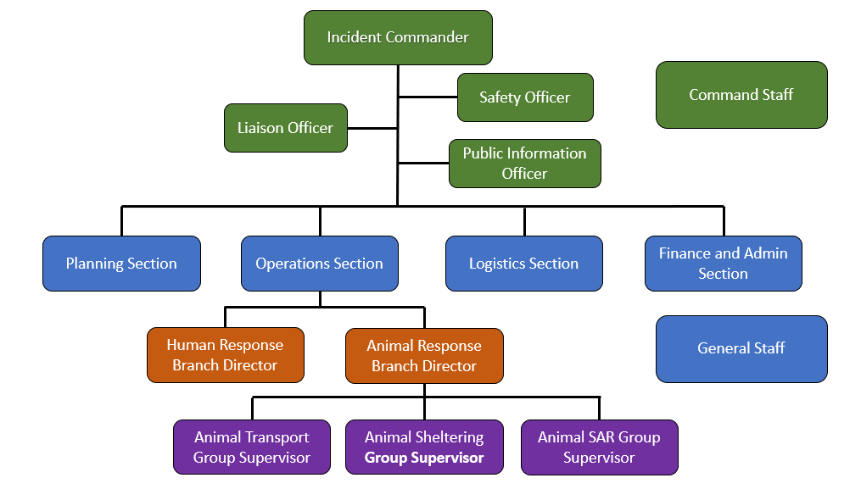
- ICS courses for response
  - All courses listed below are free and online at www.training.fema.gov
  - Completed at your own pace
  - Courses that are recommended and may be required before deployment depending on the agency
- IS-100 Introduction to the Incident Command System, ICS 100
- IS-200 ICS Basic Incident Command System for Initial Response, ICS 200
- IS-700 An Introduction to the National Incident Management System
- IS-800 National Response Framework, an Introduction
  - Recommended
    - IS-10 Animals in Disasters: Awareness and Preparedness
    - IS-11 Animals in Disasters: Community Planning
    - IS-111 Livestock in Disaster
  - Other courses are available that are online or in-person for those wanting to further their NIMS/ICS training
  - Other courses may be required or recommended to be eligible for deployment and is up to the individual response organization
- Credentialing
  - Department of Homeland Security (DHS)/Federal Emergency Management Agency (FEMA) definition: having provided, or providing, respectively, documentation that identifies personnel and authenticates and verifies the qualifications of such personnel by ensuring that such personnel possess a minimum common level of training, experience, physical and medical fitness, and capability appropriate for a particular position
  - Essential in the emergency management community since it ensures and validates the identity and attributes (e.g., affiliations, skills, or privileges) of individuals or members of response teams through standards
  - Established standards allows the community to plan for, request, and have confidence in resources deployed from other jurisdictions for emergency assistance.
  - Ensures that personnel resources match requests, and it supports effective management of deployed responders.
  - For a more information concerning credentialing, see the NIMS Guideline for the Credentialing of Personnel at https://www.fema.gov/pdf/emergency/nims/nims_cred_guidelines_report.pdf
- Resource Typing
  - Supports a common language for the mobilization of resources (equipment, teams, units, and personnel) prior to, during, and after major incidents
  - Resource users at all levels use these definitions as a consistent basis when identifying and inventorying their resources for capability estimation, planning, and for mobilization during mutual aid efforts
  - National NIMS resource types represent the minimum criteria for the associated component and capability
  - Resource Typing Library is a searchable tool for determining necessary qualifications for positions and teams
    - https://rtlt.preptoolkit.fema.gov/Public
    - Use the search function and type in “animal” to see qualifications needed for animal specific positions and teams

Notification Process
There are some unique challenges within the notification process when animals, especially livestock, are involved. Incidents involving vehicles, humans, and roadways will most likely come through the normal 911 Call Center, but many other requests may come through a variety of other channels including, but not limited to, animal services/control, N.C. Cooperative Extension (NCCE), local veterinarians, direct to volunteer/rural fire departments, or even someone reaching out on social media for help. In many instances, the incident is handled by neighbors helping neighbors and unfortunately the outcome can be less than ideal since many have limited or no education on response techniques. It is also likely that county-to-county mutual aid agreements have not been established for animal response resources but if each county can identify what they have available, this step can be streamlined. Another roadblock is that if the request makes it up to the state level, state personnel also have limited training and access to resources for animal emergencies, especially if livestock are involved. There are some volunteer organizations throughout the state that can respond but it may take several hours for them to arrive on scene depending on availability of personnel and location of the incident. There are also limited veterinarians trained in emergency response along with limited access to livestock veterinarians in many rural areas. These are all reasons why first responders should have at least rudimentary training/awareness of animal response techniques.
Some areas that can make a response more effective is to know what to expect upon arrival. Very few call centers have dispatcher decision trees built into their software that directly relate to animal incidents. Having an internal document created for animal related incidents for dispatchers to follow could assist in capturing some important information to improve response time and efficiency by responders. Knowing whether animals are trapped inside a trailer, loose in the roadway or located several miles from the nearest access point will make a huge difference on what kind of personnel and resources will be needed on the scene. Below is a sample dispatcher decision tree. A printable pdf version can be found in Appendix E. It can be modified to fit the most common incidents anticipated in each jurisdiction. There are Animal Emergency Incident Assessment templates for incidents that do and do not involve transportation located in Appendix D that may be useful for dispatch.

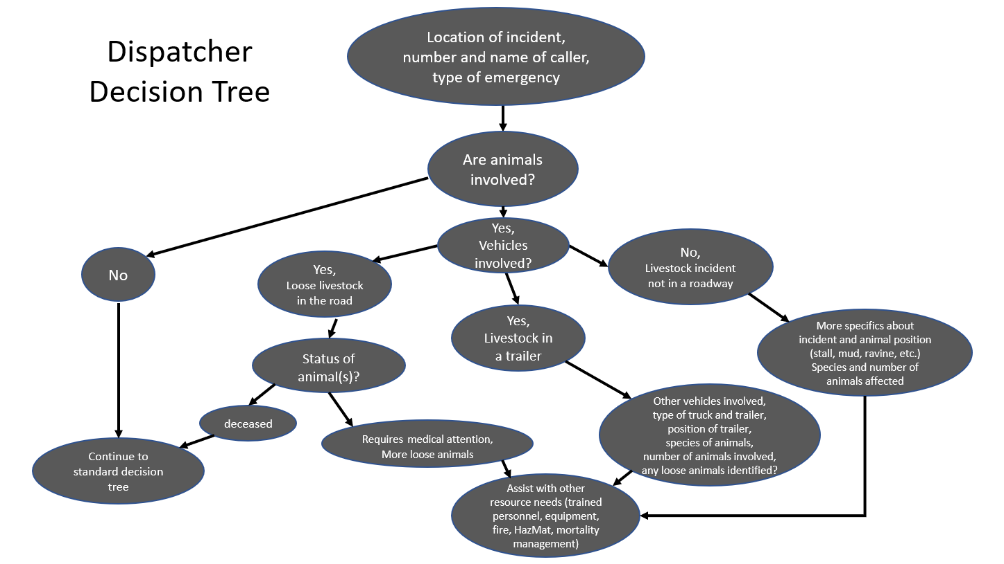
Animal incidents follow the same notification process as any other incident for getting additional resources. If it can be managed locally with what is already on the scene, it is. If more resources are needed, those resources that are local should be used first. If the resource request cannot be filled locally (with county resources), emergency management can reach out to surrounding counties through mutual aid. If resources are still not available, the request is then pushed up to the state level. The more resources that can be identified and utilized locally, the quicker the incident can be resolved, and a more favorable outcome achieved. The Notification Process graphic can be found in Appendix F as a printable pdf.
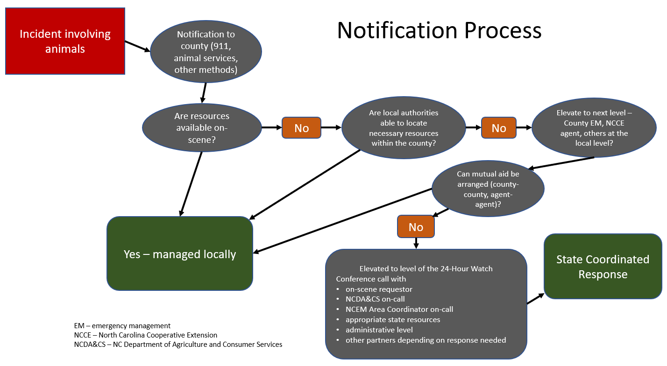
Resource Identification
Identifying resources prior to an incident will save time and stress during an incident. If gaps in resources are discovered, reach out to partners and stakeholders within your county to see what is available. If certain resources are not available in your jurisdiction, identify other jurisdictions that may be able to help. Some potential resources to identify are listed below and there is a sample resource contact list in Appendix C to use or modify as needed.
      - Create a contact list for personnel
- Animal Control/Services
  - Jurisdictional responsibility, animal-based resources (especially for small animals), animal behavior experts (may not include all species), law enforcement for animal violations, serves as the animal advocate if the owner is unavailable/too emotional, may be a certified euthanasia technician (species dependent)
  - Livestock involvement varies by county/jurisdiction, often limited emergency response training
- Fire department (primary resource for technical rescues)
  - Local agency to respond first to many emergencies including animals
  - Technical skills and equipment available even if not specific to animals, established communications and working relationships with other agencies, ICS training, scene management, personnel
  - May have farm/livestock experience, especially in rural areas
  - Limited training in animal rescue situations
- Law enforcement
  - May be the first on-scene, especially if roadways are involved
  - First aid skills, ICS training, established communications and working relationships with other agencies, scene security including traffic and crowd control, assist with managing the owner/family at the scene
  - May or may not have animal response training or farm/livestock experience
  - May be able to assist with euthanasia if needed
- Veterinarians
  - Most qualified to assess the animal’s medical condition including prognosis and treatment options, species specific handling equipment, experience and behavioral expert, access to medications (sedation, anesthesia, fluids, after-care for wounds/injuries, euthanasia)
  - May only treat certain species (knowledge, comfort level, and available medications), may not be readily available/have delayed response time, often not trained in emergency response/ICS
- N.C. Cooperative Extension (NCCE)
  - Livestock agents have local contacts for resources (equipment, sheltering, personnel, etc.), may have some assets owned by the county Extension office, animal behavior experts
  - Limited training in response/ICS, may not be available during an incident
- Animal Emergency Response Organizations
  - Experienced with safe rescue techniques and equipment, ICS trained, many are willing to assist over the phone if not available, offer trainings
  - Most are volunteers and may not be available when needed (distance or time) for assistance
- Livestock commodity organizations (cattle, equine, sheep, swine, poultry, beekeepers, etc.) (https://localfood.ces.ncsu.edu/local-food-production/nc-commodity-organizations/)
  - Behavior experts for their species, know local resources
  - Many are not trained on response techniques or know ICS
  - Potential funding sources for training or equipment
- County Animal Response Teams (CART)
  - Potential source of trained volunteers from within the county that have at least introductory experience with ICS
  - Many not have large animal experience or training in technical rescue
- Wrecker Services/Heavy Equipment Operators
  - Able to lift animals and trailers, already on the scene for roadway incidents
  - May have limited access in remote locations or inside structures, can cause serious injury to responders and animals if not trained, may have limited knowledge on rescue techniques and animal behavior
- Emergency Management (local and state)
  - Access to resources at the local, regional, and state level; assist in preparedness activities
  - Most likely have limited animal experience (behavior and rescue)
- NC Wildlife Resources Commission (NCWRC)
  - Law enforcement division, legal jurisdiction over wildlife, can assist with crowd control and scene security, may be able to assist with euthanasia of wildlife
- NCDA&CS – Veterinary Division (State Veterinarian, Livestock and Poultry Health Sections), Emergency Programs Division
  - Have contacts across the state that may have available resources
  - Limited personnel, training, and equipment
      - Create a contact list for resources and associated costs
        - Specialized equipment for extrication
          - Ropes, straps, rescue sleds/glides, slip sheet, rigging, webbing, slings, cutting equipment, etc.
        - Trucks and trailers to relocate live or deceased animals (see Animal Relocation for more information)
        - Equipment to load deceased livestock
        - Sheltering/treatment facilities if unable to be transported back to owners
        - Corrals, panels, portable or makeshift fencing for containment
        - Species specific handling equipment
          - Halters, lead ropes, hog sorting boards, flags, etc.
        - Very specialized equipment – helicopters, cranes, mega tow trucks
      - Determine the need and create Memorandums of Understanding (MOUs)/Memorandums of Agreement (MOAs) for unavailable resources
      - Create a plan/call down list
        - Exercise plan (virtually, in-person, tabletop, or full scale)
Scene Arrival and Assessment (Although many recommendations below are for a livestock trailer accident, the concepts/actions are applicable to any incident involving animals.)
- Get as much information from the reporting party as possible
  - Type of incident
    - Single animal in compromised position
      - Examples include cast/stuck in a stall or under/through a fence/gate, stuck in hay loft – can walk upstairs but not down, down a ravine, in mud, water rescue, fell through a bridge in a remote area, stuck in or through something such as panels, tractor tires, feed/water troughs, etc.
    - Multiple animals in need of rescue
      - Examples include severe weather, hazmat with decontamination requirements (radiological or biological contaminations), barn/structure collapse, fires (wildfire, barn), etc.
    - Loose livestock in the road with potential human injuries
      - Examples include domestic animals that have escaped their fencing due to numerous reasons, trailer accident, trail riding accident, herds of wildlife in the road, moving animals down the road to new pastures, etc.
    - Incident involving livestock and a trailer
      - Examples include an animal falling down or becoming trapped in the trailer, falling through the trailer floor, involved in a vehicular accident with or without entrapment, animals stuck on a trailer during inclement weather, etc.
- Only personnel essential for response should be on the scene
  - Need to stay as calm and quiet as possible – since most livestock are prey species, they tend to be more reactive when people are agitated/stressed
  - Block the scene from the public and media (handle with the same sensitivity as a human response)
  - Maintain a wide perimeter of the scene especially if loose livestock are present
  - Depending on incident size and location, ensure a PIO is on scene who understands the sensitivity of accidents involving animals
- Limit loud noises as much as possible
  - Sirens
  - Bull horns
  - Loud talking
  - Shouting
  - Radios
- Be cognizant of bright lights, especially at night (animals have good night vision, but it takes twice as long for their eyes to adjust between light and dark as humans)
  - Can make animals startle and depending on the species, either run away/try to evade or attack
  - Limit the number of flashing lights, flashlights especially pointed at their faces, headlights, etc.
  - When moving animals in a controlled manner, they prefer to go from dark to lit areas – can be used to your advantage
- Follow the basic principles of any rescue operation
  - Handle life-threatening situations first (humans before animals)
    - Fire, traffic, water, loose or dangerous animals, adverse weather conditions, etc.
  - Secure all structures before entering or attempting extrication
    - Trucks, trailers, buildings, etc.
- Look for the bill of lading or in case of emergency (ICE) forms
  - Can get from driver if coherent or find in the cab of the truck
  - Will provide valuable info on the load and contact information to provide to dispatch
  - If it is company owned livestock, majority will have their own response teams and will handle the livestock related issues
- Animal assessment (after human assessment)
  - Check all compartments of the trailers for humans or other animals (e.g., living areas, tack compartments, goose neck)
  - Maintain documentation of all animals and conditions for the accident report, including loose animals that left the scene
  - Do not attempt to move animals (either in or out of trailer) until you have a plan on where those animals need to go
    - Do not stick things (arms, legs, sticks, lights, etc.) into trailer prior to extrication procedures
  - Determine extent of injuries and need for immediate treatment
    - Begin with a visual assessment (may be the only assessment that can be done depending on the animal and location) to be relayed to the veterinarian over the phone or when they arrive on scene
      - Awareness level of the animal(s)
        - Alert, agitated, depressed, unaware of surroundings, etc.
      - Respiratory rate and effort
        - Indication of fear, shock, chest trauma, pain, heat stress, etc.
        - Normal vitals for major species are listed in Appendix H
      - Shivering in all species or sweating in horses can be indicators of environmental stress
      - Lameness/limping or non-weight bearing
      - Evidence of blood, active bleeding, open wounds, visible bone, impaled objects, etc.
  - Euthanasia may be the best course of action if it is determined that an animal has obvious severe injuries that are incompatible with life or have a long and painful healing time
    - If animals are easily accessible, obtain permission from owner or person having legal authority to euthanize ASAP to prevent further suffering
      - Get advice from a veterinarian, if possible, or other trained livestock person if a veterinarian is not available
      - Document all conversations and if possible, get recommendations and permission in writing
    - If animals are trapped and not accessible, see further details under the Extrication/Recovery Section
    - See Euthanasia/Depopulation section for more information
  - Secure loose livestock before releasing ones that are still contained to protect personnel and maintain traffic safety
    - More details on containment options are in the Incidents Involving Livestock Trailers section
    - See Animal Behavior and Handling section on how to move livestock
    - Animals that are stressed and/or pushed can jump higher or go through things that you would not expect
- Determine additional resource needs (see Resource Identification section)
  - People
  - Equipment
- Management of untrained volunteers
  - When animals are involved, volunteers will appear out of nowhere
    - Many are not trained in ICS or response
    - May not understand animal behavior
    - Can be a major liability
  - Keep them as far away from the danger zones as possible
    - Use law enforcement if available to secure the scene
    - Give them something to do that is out of the way but makes them feel useful (“hold this rope/chain/panel until we need it” – e.g., “go boil some water”)
Responder Safety
- Personal Protective Equipment (PPE)
  - Besides the animals, what else is at the incident that would require PPE?
    - Hazmat spill, biological material, fire, adverse weather conditions, traffic, water, sharp objects, etc.
    - Use appropriate PPE such as Personal Flotation Devices (PFDs) when near water, safety vests in traffic, etc.
  - As with any animal response, assess what can go wrong, assume it will, and determine the best course of actions to prevent injuries to humans first and then the animals
  - Helmets!!
    - Need to protect the head from flying/flailing hooves and heads during large animal rescues
    - Designed to withstand the rigors of the environment
    - Narrow brim and a non-stretch chin strap with 3 suspension points (one on each side and in the rear) are essential
      - Don’t want to obstruct vision since animals can react quickly and unexpectedly
    - Rigid shell to withstand impact and penetration by sharp objects
    - Can be made from plastic, fiberglass, or Kevlar composite
    - Construction and motorcycle helmets are not good rescue helmets
    - Fire helmets tend to be cumbersome in high angle environments
  - Foot protection
    - Close toed is required, steel or composite toe is recommended
    - Comfortable
    - Provide ankle support
    - Protect against penetrating injuries
    - Soles should have reasonable amount of adhesive quality
  - Gloves
    - Provide comfort, protection, and adhesion while being able to perform the necessary task
    - Heavy duty enough to prevent cuts and abrasions for the work being done
    - Able to be decontaminated or disposed
  - Respiratory protection – dependent on environment and determined by the IC and/or Safety Officer
  - Eye protection – dependent on the environment and determined by the IC and/or Safety Officer
  - Hearing protection – assess requirements based on species of animals (swine!) and equipment being used
  - Body protection
    - Will depend on risk of contamination and risk of injury
      - Contamination risk – wear coveralls, Tyvek suits, etc.
      - Injury risk – protective vest/chest protector
- Animal Danger Zones
  - Always have escape routes identified
  - If animal is standing:
    - The safest place to approach is at the shoulder
      - Animals are usually more comfortable being approached on the left side since most of their training occurs on that side (majority of people are right-handed)
    - Blind spots directly in front and behind
    - Wide arc for hind limbs to kick, especially cattle (cow kick)
    - Be wary of the head and neck being slung
    - Can strike with front feet and/or rear up
  - If animal is down lateral (on side):
    - Work in the area along their back but away from the neck
    - While flailing, head, neck and legs will move faster and farther than expected
      - See picture below and do not stand in any of the red areas even if the animal appears to be unconscious, sedated, or under general anesthesia
    - Maintain constant vigilance and be ready to back up quickly because they can roll over faster than anticipated and when least expected
      - Depending on the situation, a tag line and someone ready to pull back and/or make sure nothing is impeding an escape route (people, equipment, structures, etc.) can be beneficial
  - If animal is down but sternal (laying on its chest):
    - The front end of the animal poses the greatest risk of injury to the responder especially if they start to thrash, throw legs up to stand up, or roll over onto their side.
      - Work between the base of the neck to the tail region of the animal
      - Horses throw front legs forward when they prepare to stand up and cattle get up in the hind end first
    - Maintain situational awareness if the animal tries to get up or goes over onto their side
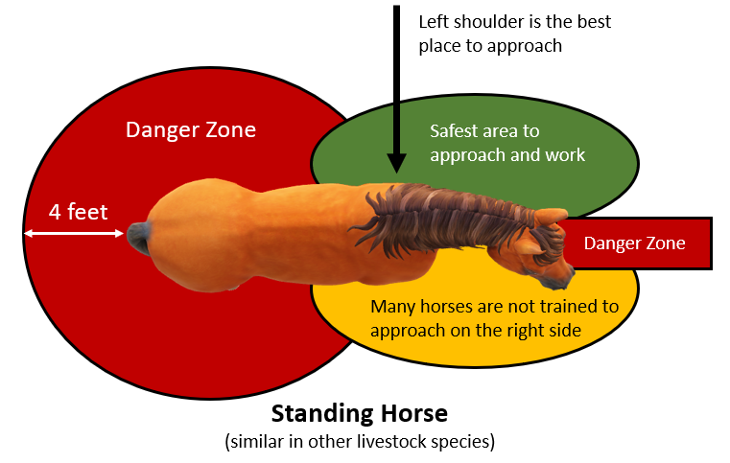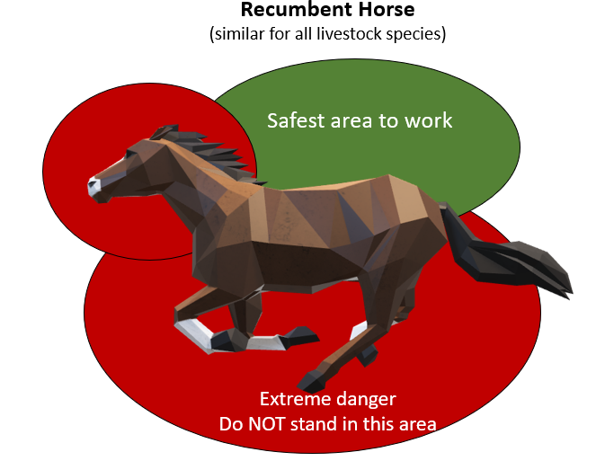
Biosecurity
- The measures to prevent the spread of infectious disease(s)
  - From the incident to the responders/public (zoonotic diseases)
  - From the incident to the relocation site and the animals that normally inhabit that premises
  - From the incident to the responder’s and/or public’s premises and animals
- Stressed animals are more likely to shed infectious particles even if they appear healthy
- Sources of exposure include the actual animals and any bodily fluids (urine, manure, blood, respiratory droplets, etc.) and aerosolization of any contaminated material
- Ways to limit spread/improve biosecurity:
  - Decrease the number of people exposed by limiting who has access to the scene and animals
  - Requires the proper use of PPE to prevent the spread of diseases to responders, the public, and other susceptible animals
    - Impermeable boots, disposable gloves, respiratory protection (n95 or higher), face shields for splash protection, and Tyvek suits are some examples depending on the possible pathogens encountered
    - Dispose of PPE appropriately to prevent environmental contamination
  - Use proper cleaning and disinfection to decrease the spread of pathogens
    - Most disinfectants are inactivated by organic material (feces, dirt, bedding, etc.)
      - Clean surfaces well (soap and water if available, dry brush and elbow grease if not) before applying disinfectant
    - Most disinfectants need specific concentrations and contact time to be fully effective – read the label
Animal Behavior and Handling
- Body language
  - Animals are not good at subterfuge and will tell you exactly what they are planning if you know how to read them
  - Generic for all species (Species specific terminology and behavior is in Appendix G)
    - Calm
      - Ears – drooped/relaxed but still aware of surroundings and listening
      - Head – in a neutral position (not elevated or dropped to the ground unless eating)
        - Cattle, sheep, goats – if not actively eating, may be chewing cud (will not be chewing cud if scared/nervous)
      - Body – muscles are relaxed, may be standing or laying down
        - Swine – may be rooting with nose and grunting
      - Eyes – soft, could be partially closed if drowsy
      - Tail – relaxed, may have some swishing if biting insects are present
      - Legs/hooves – may have hip cocked and resting a back leg, standing still or walking slowly
    - Alert/curious
      - Aware of surroundings and determining what action needs to be taken next
      - Ears – upright, pointed towards the area of concern
      - Head/body position – head is held high for a better view; body is tensed and ready for action if needed
      - Eyes – wide and watching area of interest
      - Tail – tense and slightly raised
      - Legs/hooves – still may have hip cocked or all 4 limbs are ready for motion depending on level of concern
      - Vocalizations – species dependent but horses and cattle may snort or blow in the direction of concern, swine may squeal or grunt
    - Agitated, scared
      - Ears -twitching from side to side or erect and pointed towards area of concern, intently listening
      - Head is normally up and whole body is tensed but may be dropped towards the ground and watching
      - Eyes – wide open, startled appearance
      - Tail is either tightly clamped down or frantically swishing
      - Hooves are typically planted but ready for quick movement
        - May have a back leg cocked – ready to kick or run if something gets too close
        - Front hooves – may paw the ground
      - Depending on species – increased vocalizations (whinnying, squealing, mooing, bleating, etc.)
      - Contemplating next action – run or attack
        - Body position will give an idea of which direction they will run –straight (forward) or curved/bent
      - Animals that are scared will normally try to evade but some will attack especially if cornered
        - Some scared animals will go through or over whatever is in their way when cornered, including fences, vehicles, people, buildings, etc. resulting in severe damage to humans, property, and the animals themselves
    - Angry/aggressive
      - Ears – pinned back to the skull is the most common but can be straight up, watch for other body signs to know if they are looking to run away or attack
      - Face/muzzle – if in a species that bites (horses, dogs, cats), upper lip can be curled up and teeth maybe showing
      - Head/neck – can be upright or down towards the ground but whole body is focused on a target
      - Feet and legs
        - Front hooves – pawing or stomping the ground
        - Hind legs – hip cocked and aiming body, cattle will kick in an arc (“cow kick”) whereas horses are generally straight front and back
      - Body
        - Depending on species
          - Horses, goats - rearing up or making aggressive forward movements
          - Cattle, sheep - if they back up and lower their head, they are getting ready to charge or head butt/ram
  - See Appendix G at the end of the guide for more animal behavior by species
- Flight zones
  - Approach at the animal’s shoulder and not directly at their face
    - Predators attack the head and tail regions of prey animals
  - Appear non-threatening – majority of animals are prey species and have a large flight response when approached by something perceived as a predator
    - Keep hands and arms down by your side, eyes averted (not direct eye contact – predators stare their prey down), walk slowly (sometimes even approach with back turned) and observe the animal’s response whether you can continue moving towards it or need to stop
  - Some animals will approach people with the rattling of a bucket or crinkle of a plastic wrapper if they are used to getting grain or treats
    - Can place small rocks or dirt in the bottom of a bucket (or helmet) to rattle if no grain is available
  - How to manage loose livestock
    - Do NOT chase animals – they are faster and can run farther than most humans
      - If they are calm and grazing on the side of the road, they may remain there as long as they are not excited/chased until additional help can arrive.
      - Most livestock are herd animals and may return to the herd on their own
    - Have a location identified to move them to (open pasture, temporary containment area, etc.)
      - Livestock have a hard time making sharp turns so approach openings from an angle or head on
      - If using temporary fencing or corral panels, create openings as a funnel, where animals enter at the widest area
      - They do not like entering dark and/or confined spaces
        - Use this to your advantage whenever possible - move towards a lighted area and use fencing that is not solid and can be seen through
    - Keep calm and quiet – it takes 30 minutes for agitated animals to become relaxed
      - They feed off of human emotions and if the handlers are excited, the animals will also become excited, but if the humans stay quiet, the animals are more likely to stay calm and go where you want
    - Flight zones
      - See diagram below for how to approach an animal to achieve the desired direction of travel
        - Use their point of balance (shoulder area) to control direction of travel
        - In front of the shoulder – most will turn away or back up
        - If approach behind the shoulder – most will move forward
      - Size of flight zones – dependent on previous exposure to humans, training, and excitement level
        - Example – range beef cattle may have a 100yd+ flight zone whereas the dairy cow may have none
      - Using solid boards (hog sorting panels, plywood, etc.) or arm extensions (flags, sticks, etc.) can be useful when moving certain species

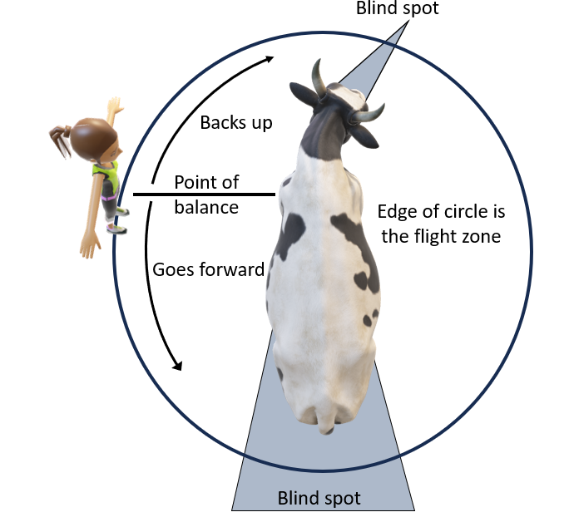

    - Blind spots
      - Most animals have a wide range of vision but cannot see directly behind or in front of them (if you can see their eyes, they can see you)
      - Approaching/sneaking up to an animal in their blind spot is a good way to get kicked – predators sneak up on animals in their blind spots
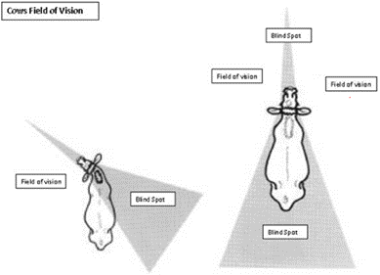

    - Keep animals together – they are herd animals and calmer when in a group
    - Do not separate/get between a mom and her baby in any species
      - Can be used to coax mom to follow if you have baby but do not turn your back to mom
    - Intact male animals can be extremely dangerous and always proceed with caution when working around them
      - Tend to be larger, more muscular, and more aggressive than castrated males or females
      - If within a breeding herd, can be very possessive of their females/territory and be very defensive
- Haltering
  - Put a rope around the neck or another form of restraint prior to putting the halter on to reduce the risk of them walking away/escaping before fully haltered
  - Proper Placement
    - If too high on nose:
      - Limited control of the animal and depending on halter type
      - Ride up into their eye and cause damage
    - If too low:
      - Can obstruct airflow and potentially damage sensitive cartilage at the end of their nose
        - Some animals cannot breathe out of their mouth so obstructing airflow through their nose can be fatal
      - Can slip off end of nose and then animal is not well restrained
    - If too loose:
      - Objects (own legs, pieces of equipment, etc.) can become entangled
      - Slip off/over nose or ears and then animal is not restrained
    - If too tight:
      - Unable to open mouth (stressful and unable to eat)
      - Damage to underlying bone and muscle
    - Correct placement:
      - Placed behind both ears (sounds simple but can be difficult to see in the dark, moving animals, and/or with lots of hair/horns in the way)
      - Nose piece is a 2-3 inches (a couple of finger widths) below the crest of the facial bone (continue to monitor especially with rope/makeshift halters because they can easily slide up towards eyes)
      - See picture below for examples of proper fitted halters
        - Note that the rope/adjustable halter has the long/free end coming out under the jaw on the left side of the animal and the fixed piece is over the nose
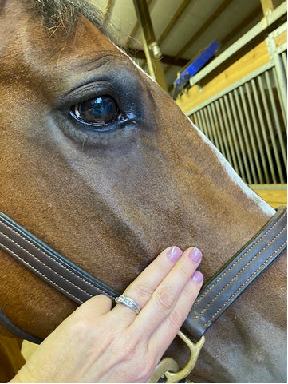
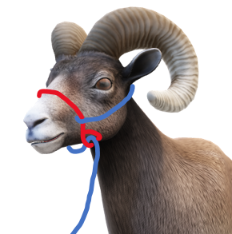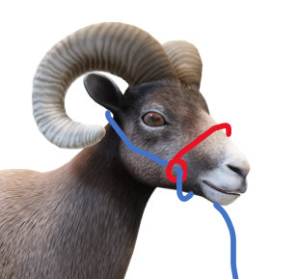
  - Horses are generally trained to lead by a halter and rope (some horses such as bucking stock, mustangs, and young horses may not be)
    - Lead from the animal’s left side (or on the right side of the person)
    - May already be haltered if involved in a trailer accident
    - Many halter options available: nylon, leather, rope, etc. – know how to apply a halter
  - Cattle – only show cows (beef and dairy) are halter broke
    - Assume cattle are not trained unless they are already tied up in a trailer for transport
  - Sheep and goats – majority are not trained
    - Still small enough that a halter/rope can be used to restrain the animal if needed even if not halter broke
    - Be aware that they can act very dramatic if not used to a halter (throw themselves on the ground and act like they are dying, jump into the air, or a combination of both)
  - Camelids (llamas, alpacas, camel) – majority are not trained
    - More sensitive to lower halter placement than other species and easily cut off airflow if not careful
    - Many will lay down and refuse to get up when being led or stressed
  - Emergency halters can be made from a piece of rope – see diagram below
    - Can be used on any animal if they are halter broke
    - Only used to lead to a safe location and not used to tie the animal - the rope will slide off the animal’s nose and they will be free
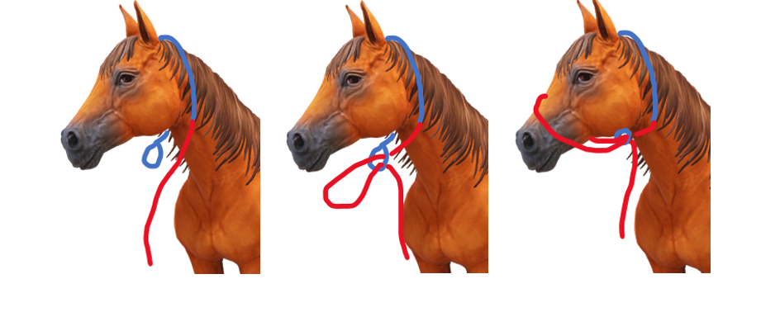
- Tying
  - Do not assume any animal can be safely tied even if they are halter broke
  - Ensure that animal is tied to a secure structure that cannot be moved by a 1200-pound animal that is frightened
  - Height in which to tie
    - Head at a relaxed/neutral position
    - Tie no lower than their withers (where the neck joins the body)
  - Length of rope
    - Long enough that you can safely reach the free end of the rope
    - Not too long that animal can get a foot over, turn around, etc. Maximum length should be that nose can just touch the ground
    - Not too short that the animal is pinned to the tying object or head is held up or down depending on the tie point
  - Only use lead ropes with quick release snaps or quick release knots
    - Make sure the quick release portion is easily accessible if the animal gets tangled (not used near the face since it will end up under the animal if they flip over or will be near striking hooves if become agitated)
      - Be aware that the weakest point and most likely portion to break if an animal panics is the snap
      - Use appropriate sized hardware for the species of animal that is being restrained
        - If too big – can be burdensome for the animal to carry
        - If too small – animal can snap the hardware or rope when panicked which can endanger the people and other animals nearby
    - See diagram below on how to tie the most commonly used quick release knot
    - Although some animals know how to release certain knots, do not make the quick release end so difficult to undo that it is now not a quick release

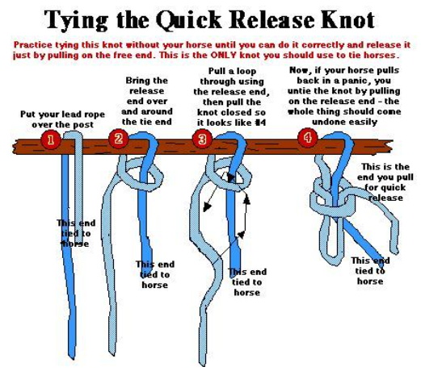

Introduction to Technical Large Animal Emergency Response (TLAER)
- Human safety is ALWAYS the number one priority
  - Situations will arise where it is best to euthanize the animal instead of risking the health and safety of responders (either too aggressive to safely handle or extrication is too dangerous)
- Keep the response as simple as possible (KISS method)
- Be flexible/adaptable
  - Animals do not always react in a predicable manner so need to be willing to change plans and adapt as needed
- Basic TLAER techniques – awareness only
  - Protection for the animals while rescuing
    - Downside eye protection (towel, commercial head protector, PFD, anything to place between the head and the ground)
    - Body protection if sliding (rescue glide, etc.) – cover abrasive or hot/cold surfaces
    - Veterinarian on-scene to monitor, sedate, or put under general anesthesia
    - Winches should NEVER be attached to an animal as a tool for extrication
  - Basic to-go kit
    - Rope halter, 10+ft lead rope, arm extension (cane, etc.), webbing straps (30ftx3-4in), eye protection for the animal, hobbles (round slings), wire cutters/fencing tool, loppers (small or expandable), blunt end scissors, knife (sharp), hay/grain/treats
  - Do not use the head/neck or tail as pulling or lifting points
  - Basic webbing configurations - dependent on the location and position of the animal needing to be extricated
    - See Awareness Course training slides for pictures of configurations
    - Forward assist
      - Used to assist an animal out of an entrapment
      - Can be used for standing, sternal, or lateral (on their side) recumbency
      - Configurations
        - Basic configuration
          - Short term use
          - Not used for lifting since they can slide out
          - Under arm pit, over withers, under opposite side armpit – both ends of strap are in front of animal
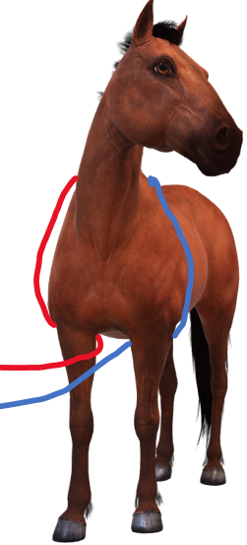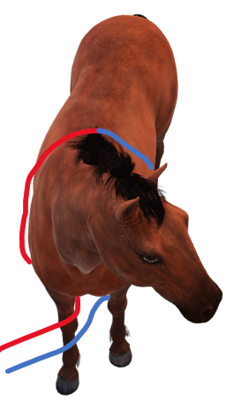
        - Larks foot/choker configuration
          - Short term use
          - Will constrict around ribs and affect respiratory effort
          - Can be used to lift (last resort) but must be loosened immediately
          - Loop at end of strap is placed at chest between front limbs, long end of strap is between front legs, over withers, back between front leg and through the loop – only 1 pulling strap
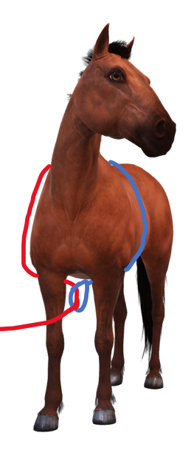
        - Swiss seat configuration
          - Short term use
          - Most secure option but most difficult to apply
          - Increases surface area and distributes pressure
          - Can be used to lift and does not restrict respiratory effort
          - Middle of strap is placed on chest where neck ties into body, both ends are taken over withers where they cross, then run each end behind elbows and through front legs, feed back through the middle piece of strap across the chest
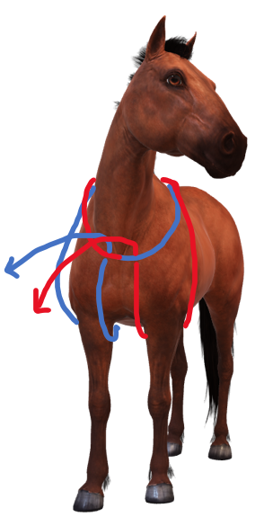
    - Backward assist
      - Basic configuration
        - Short term use
        - Due to location of webbing – use extreme caution when applying and removing
        - Can slide/maneuver out if there is slack in the webbing
        - Do not lift
        - Over hips, around flank, and pulled between hind legs
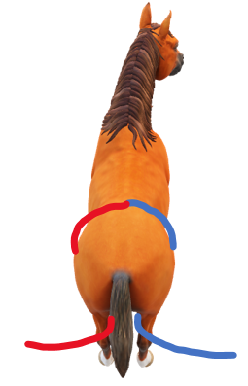
    - Sideways assist
      - Basic configuration
        - Be extremely cautious applying and removing webbing in the flank region (rear)
        - Top and bottom webbing strap must be pulled with the same force
        - 1st strap placed around chest behind elbows, 2nd strap placed around abdomen in front of hind limbs
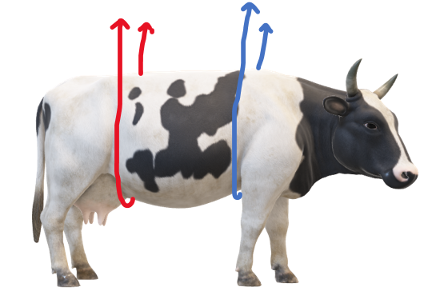
      - Hampshire slip configuration
        - Must be pulled evenly and consistently
        - 1st strap is under chest, looped over bottom forelimb, and pulled back under chest. 2nd strap is under abdomen, over down back leg, and under the tail
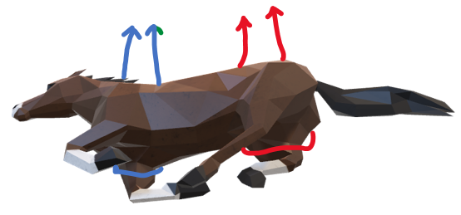
    - Rolling
      - Downside leg – can be rolled by only using the rear leg but easier if both are used
        - Rope/webbing is placed at the level of the pastern (above hoof and below first large joint)
        - Use extreme caution when applying and removing rope/webbing – use hand extensions
        - Stand far enough away that when the animal rolls over, you are out of range of their hooves. Standing at their back, pull webbing/rope that is on hind limb towards their shoulder and the one on their front leg towards their hip. This will prevent the legs from straightening and making it more difficult to roll. It is also helpful to have the head and neck pulled forward.
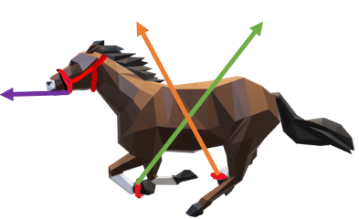
    - Lifting – contact trained personnel to assist and a veterinarian should be on-scene before attempting
      - Sedation or anesthesia depending on location and condition of animal
        - Veterinarian is required for administration and monitoring
      - Performed only by technically trained personnel
      - Appropriate PPE for all directly involved
      - Appropriate weight rated webbing at least 4-8” wide
      - Straps secured in place with a spreader bar
      - Use some form of quick disconnect
      - Leave plenty of room above the animal’s head

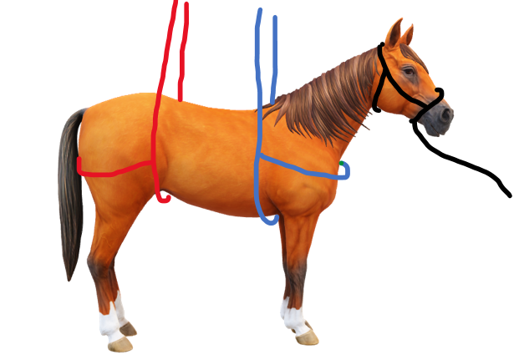

Animal Extrication/Recovery
No two incidents are the same but certain principles should be followed for all incidents to ensure the safety of the responders and public and to achieve the best possible outcome for the animals involved. More information pertaining to specific types of incidents is listed below under that section.
- Use appropriate PPE (head, hand, foot, and body protection) to prevent traumatic injuries and contamination by biological substances
- Move all people and animals that are not needed to for the extrication out of the area before starting
- For complicated cases, have a veterinarian(s) assist
  - Available for sedation or general anesthesia
  - Perform medical evaluation to determine prognosis and whether euthanasia is recommended
- Use extension devices (poles, hooks, etc.) to apply ropes/webbing whenever possible to keep responders out of danger zones
- Use appropriate techniques to safely extricate animals that cannot self-free
  - Contact trained TLAER personnel if responders are not trained, or scene is too complex
  - Have a veterinarian sedate or anesthetize if possible and as needed to prevent injuries to responders and animals
  - Cover downside of animal’s face to prevent damage to the eye
    - Commercially available head protectors or other alternatives such as a life vest
  - It is hard to predict when an animal will react to rescue efforts so always stay out of kick and pinch zones
  - Do not use the head, ears, or tail to drag animals - use the body or legs
  - Do not hook to mechanical equipment or vehicles to drag animals
    - Can use mechanical advantage – know how to use ropes and rigging
    - May need to lift animals, use appropriate equipment (webbing, sling, spreader, farm equipment, wrecker service, crane, helicopter, etc.) that is rated to handle the weight

Common Types of Incidents Involving Animals
Animals can get into all kinds of trouble in all kinds of locations. Below are a few of the more common situations that animals can find themselves in.
- Loose livestock in/near roadways
  - Probably the most common situation encountered with livestock in any location
  - Carefully approach the scene especially at night or whenever visibility is poor
  - If possible, block the road to prevent further traffic
  - If an accident has occurred, assess human injuries and then animal injuries
    - Contact a veterinarian that treats that species if needed (see county contact list)
  - Determine where animals came from (nearby pasture with damaged fence?) and locate owners if possible
    - Contact Animal Control/Services
      - May know who the owners are especially if repeat offenders
      - Jurisdictional authority over loose livestock and can fine or confiscate as needed
      - Can authorize medical treatment including euthanasia for injured animals if owners cannot be located
    - If available, NC Cooperative Extension Livestock Agent may know who owns animals in the area
  - Use animal behavior to place animals either back in their own pasture (ensure they cannot get back out) or use temporary/portable containment options to hold animals in a safe location while waiting on a truck and trailer for relocation
    - Do not chase – you cannot outrun them, use animal behavior to get them where you want
- Incidents involving livestock trailers
        - Includes animals injured in a trailer without being in a motor vehicle accident (poor trailer integrity and fell through the floors or kicked through a wall, animals trapped under/over dividers or through narrow openings like escape doors or windows, etc.), single vehicle accidents, and multi-vehicle accidents
        - Assess outside factors such as environmental conditions that can adversely affect outcome
          - Excessive heat, direct sunlight – use water to cool the trailer, create shade via tarps, etc.
          - Excessive cold – blankets, portable heaters, warm fluids once extracted, etc.
        - It is generally not recommended to move trailers, including when righting the vehicles or trailers, with animals inside (alive or dead) except for stabilization procedures as required for safety
          - Use trained wrecker personnel if available (reference County Resource List)
          - Trailer integrity will be compromised, and live or dead stock will shift during righting activities. The trailer will be unpredictable when load shifts and may continue to roll past the desired point.
        - Do not trust any animal even if they are normally calm – they are extremely stressed and can be unpredictable
        - Have containment structures in place before extrication procedures if animals are not halter broke and able to be led safely
          - When animals see light, they tend to run towards - be prepared
          - Prevents livestock from going back out into traffic and causing another accident
          - Reduces risk of injury or death to humans and remaining livestock from loose animals
          - Reduces response time since animals do not need to be caught again
          - Containment options
            - Use what is available
              - Roadside fences
              - Uninvolved trucks and trailers
              - Involved trailer – sides, top depending on the accident
            - Bring in additional resources
              - Portable corral panels
              - Snow fencing with step-in plastic or metal t-posts
              - Be creative but safe (no sharp points, edges, etc.)
            - Can get away with suboptimal containment if animals think it is solid or too high for them to go through or over
              - Do not push them so they test the containment
            - Securing panels
              - Secure to each other at top and bottom of the panels
              - Use solid bracing (metal t-posts or solid structures) at ends and in the middle to prevent animals from dragging panels if they run into it
              - Whenever metal t-posts, use plastic toppers (or something to guard the tops of the posts) on them to prevent impalement injuries if animals try to jump over them
- If possible, make a holding area so freed animals do not try to return to the trailer (so have 2 separate containment pens that are connected)
- Look at physical properties of barriers and limitations for the species being contained
      - Gaps between panels
      - Height – too short and can be jumped over
      - Gap at the bottom for shorter livestock (can flip panels over to decrease the gap for pigs, sheep, goats, calves, etc.)
      - Enough space for all animals within the containment area
- Design the containment area to allow loading onto another trailer to leave the scene
- If available, fence in an area with plenty of grass or offer hay to keep animals occupied/content
- Don’t block access for other necessary equipment to reach the scene
- Animal extrication specific to trailers (see Animal Extrication for additional information)
    - Determine the best access points for opening the trailer
      - Make sure no animals or humans will be injured (including those still in the trailer)
        - Verify that no animals are laying against the wall of the trailer if it needs to cut
      - Numerous types of trailer configurations - assess where the best area to cut so trailer integrity is not lost but still easy to cut through and access
        - Understand how animals are loaded and how to empty all compartments especially with multiple level livestock haulers such as pot-belly trailers
        - Roof and sides are not made to be load bearing
      - Cut so the metal is bent to the side (not down on the ground) so animals are not walking across the metal (slippery and risk sharp edges)
    - Use extension devices (poles, hooks, etc.) to reach into trailers (not your arms)
    - Allow animals that are mobile to exit the trailer first
      - They will act unpredictably due to stress and fear – many will unload rapidly, but others may not be willing to come out at all
      - Try not to unload on concrete or pavement to prevent additional injuries to the animals from slips and falls (cover with a sufficient layer of sand/dirt, rubber mats, etc. if that is the only option)
      - Painted lines on the road will cause many animals to refuse to cross since it looks different than the surrounding road - cover those with sand/dirt or rubber mats also
      - Enter the trailer only after all ambulatory animals have been off loaded
    - After all mobile animals are removed, euthanize down animals where they are located if too injured to survive
      - Euthanize prior to extrication, if possible, to decrease animal suffering
        - Recognize scene sensitivity and situational awareness if using a firearm
        - If visible or within hearing distance of the public or media, inform them of what is going on and why
      - See Euthanasia/Depopulation section for more information
- Structure fire with entrapment
- Lots of combustible material in barns (hay, bedding, wood, etc.) that burn hot and quick
- Some animal buildings also have humans living above or in an attached space which may not be obvious from the outside
- Only rescue animals that you can easily and safely get to
- Full turn out gear and Self-Contained Breathing Apparatus (SCBA) can be terrifying to animals that are already scared which makes handling them even more difficult
- Stall latches, halters and ropes are difficult to manipulate with PPE
- Do not just turn loose once outside because many will run back to the “safety” of their stalls
- Response is difficult and most structure fires have very poor outcomes for the animals unless there has been prior planning and safety measure put in place
- Water rescue
- Always use Personal Flotation Devices (PFDs) when working around water even if the plan is to not get in the water
- Avoid getting into water with large livestock that are swimming since their legs can pull a person under
- Be very careful if sedation is required so the animal does not drown
- Do not use sedation if animal is not able to touch the bottom
- If sedation is required for rescue efforts, keep the head/nostrils above water level
- Still waters like swimming pools, ponds, or lakes
- Pools
- Use steps if solid and available or can be made on site
- May need to use a sideways drag to get up solid walls
        - Protect the animal from abrasions
- May need heavy equipment to lift the animal out depending on the location and kind of pool
- Ponds or lakes
- Try to get to an area with a gradual bank and lead/herd animal out
- Depending on condition – may become a mud rescue
- Moving water (rivers, flash flooding, etc.)
- Contact a swift water rescue team for assistance/guidance (beyond the scope of this manual)
- Do not pull directly to the banks if the current is fast/strong – aim downstream and at an angle towards the banks
- If possible, aim for a location on the bank that responders can easily access
- Know surroundings within flooded areas – fence lines, submerged structures, etc.
- Ice rescue with animal in open water
- Can occur when animal walks across ice for open water to drink
- Animal will lunge and continue to break ice while trying to escape
- If aimed in the right direction, they may be able to break their own path if not exhausted and ice is not too thick
        - May need a path broken for them to get to shore
- Use a halter to help direct animal to shore and keep head above water
        - Do not place just around the neck if at all possible - do not use a slip knot that can tighten and cut off air flow if it is not safe to put on a halter
- Stay away from moving legs or the head – can pull/push a person into the water
- May need to drag the animal out of the open water and onto solid ground if ice is too thick to break a path
- Use appropriate PPE – PFD, tag lines, gloves, cold water/weather gear, etc.
- Once rescued, needs prompt veterinary care
- Warm core body temperature – warmed oral or I.V. fluids
- Using external heat or blankets will not be sufficient if extremely hypothermic
- May have organ damage from hypothermia that is not immediately recognized
- Mud rescue
  - Do not have responders (and owners) get stuck in the mud also – dangerous to be near a large animal when they are trapped even if they are currently acting calm
    - Use sheets of plywood, flat boards, backboards, ladders, etc. when working around the trapped animal
  - Approach from their side or back (away from the legs) but talk to them so you do not startle them
  - Keep the animal’s head above the mud/water by using a board, fire hose inflated with air, or by holding it up – avoid using a halter or rope to stretch the horses neck up if possible
  - Apply a halter and/or leash to be used for guidance and physical restraint only
    - Not an attachment point for pulling
  - Do not pull the animal out of the mud by the head, neck, legs, or tail – use the chest and hindquarters
  - Give the animal something for traction – e.g., plywood, gravel
  - If mud is really sticky/thick, aerate or moisten the mud around the animal’s trunk and limbs to release the suction before pulling (can pull off tails and limbs with really strong suction)
  - Depending on accessibility but may need heavy equipment to lift the animal out or dig around it if unable to get out otherwise
    - Do not use excessive force via winches and vehicles – can cause severe life-threatening muscle, nerve, and bone injuries
    - Use the barrel of the animal to lift with a spreader and strap around the hindquarters and chest
    - Need a veterinarian for sedation prior to using heavy equipment for lifting or dragging
  - Most will require treatment for dehydration and hypothermia even on warm days
- Confined spaces rescue (holes, ditches, etc.)
  - Very dependent on access to the animal
    - Use confined space training safety measures (drag lines, shoring side walls, angles, etc.)
    - Do not risk responder or owner’s lives to climb into the hole/trench
    - Contact a TLAER organization for assistance if not a straightforward rescue (see Appendix A for a list of trained response organizations in NC)
- Large animals down and unable to rise without entrapment
  - Depending on the animal’s position, have a veterinarian assess for injuries that would be incompatible with life prior to attempting rescue
    - If injuries or illness are too severe, euthanize while down
      - Examples include fractured limbs, severe colic, severe trauma to head or spine, and chronic debilitating illness
    - If down for a long or unknown period of time, a veterinarian will most likely be needed to address dehydration, systemic organ failure, lung collapse, muscle soreness/cramps, etc.
    - Cattle are commonly down due to an underlying condition such as milk fever, grass tetany, or pelvic trauma from calving and treatment of the underlying condition may allow them to get up on their own
  - Animal may need sedation depending on situation
  - Assess whether a change in positions can help (facing downhill, bad leg on the down side, slippery surface, cast or rolled up against a solid object, etc.)
    - Sometimes something as simple as rolling the animal over to the other side will allow it to get up
      - Stay out of kick and head thrashing zones while rolling
  - If down on concrete, gravel, or mud, use a sled, tarp or some other material so protect the body while sliding to a better surface (sand, dry, grassy area, etc.)
  - Use eye protection for down eye
  - Prop animal up so they are sitting sternal (on their chest)
    - Being lateral (on a side) will cause their down lungs to collapse (atelectasis) along with severe muscle damage (rhabdomyolysis) that can result in kidney failure if not treated aggressively
    - Can use hay bales, pallets, tires, etc. – be creative as long as there is nothing that can injure them
  - If using heavy equipment for lifting, wear appropriate PPE (helmets!!)
    - Make sure animals are not attached to the equipment if they do get up and start walking away
    - Have a quick release mechanism available in case animal panics or tries to run off
    - Use wide webbing and appropriate lift points – contact a TLAER for assistance since this is a very dangerous procedure for the responders and animal
- Entrapment
  - All types of fencing (woven, high-tensile, barbed, twine, tape, braid, pipe, PVC, board), corral panels, feed tubs/trough, tires, round bale feeders, etc.
  - Mostly legs hung up but can have head through panels, caught at flank when they tried to squeeze between or jump over, etc. Animals can get creative.
  - Assess situation
    - How did they end up in this situation?
      - Underlying medical causes to put them in this position:
        - Severe abdominal pain (colic) and rolled into it
        - Neurological – RABIES (do not stick hands in trapped animal’s mouth), listeria, Eastern Equine Encephalitis, West Nile Virus, polioencephalomalacia, etc.
      - Poor building/pasture management
      - Poor judgement call by the animal
    - Use appropriate tools (wire cutters, jaws of life, torches, chain saws, etc.) to release animal
      - If using loud equipment, need a veterinarian to administer sedation or general anesthesia
      - Determine reason animal is in that predicament – slid under, tried to jump over, severe disease such as colic in a horse and they rolled into it, any neurological condition, etc.
        - Underlying disease can result in a poorer prognosis
    - May need to sling or support animal while removing whatever they are caught over or through
    - Treat injuries and wounds as appropriate
      - Areas that had lots of pressure applied are at risk of muscle necrosis that may not be evident for several days
- Other forms of entrapment such as building collapses or from other natural disasters like tornados
  - Situationally dependent but the same principles apply that have been covered in other sections
- Hazmat Incident requiring decontamination
  - Possible reasons for needing decontamination for animals: fuel or other hazardous chemicals that can cause irritation/damage to the skin, eye, or other mucus membranes or be absorbed systemically; flood crud, mud, manure/feces, or other biological contamination including disease causing agents like bacteria, virus, and fungi; radiological incident
  - Hazmat incident need-to-knows
    - Chemical name
    - Plume cloud and wind direction if aerosolized
    - Proximity to local animal populations
    - How much is released? (5 ounces or 50,000 gallons)
    - Veterinary contacts (state or local) for potential adverse reactions and decontamination procedures
  - Basic decontamination principles
    - Wear appropriate PPE to decrease human contamination
    - Treatment will depend on the contaminant, but the most common treatment is copious amounts of clean water, wash with a safe soap for the species, and rinse thoroughly - repeat as often as needed
    - Determine site suitability to prevent further environmental contamination via runoff or aerosolization
    - Establish hot, warm, and cold zones to prevent further spread of the contaminant
    - Have appropriate decontamination set-up appropriate for the species
      - Portable corral systems, chutes, and/or head gates will most likely be needed for cattle, sheep, and goats
      - Horses may stand for decontamination process with halter and lead rope, but some may need to be sedated for the process
      - Dogs and cats can be bathed but set-ups and protocols for mass decontamination are available
Euthanasia/Depopulation
- Definitions
  - Euthanasia: Greek term meaning “good death”. In this context, objectives are met when death is induced which causes no pain or distress to an animal.
  - Depopulation: a method by which large numbers of animals must be destroyed quickly and efficiently with as much consideration given to the welfare of animals as practicable, given extenuating circumstances
- Reasons for immediate euthanasia
  - Any animal that is a significant threat to humans (severe aggression, heading towards a busy intersection, etc.)
  - Severe injury including but not limited to:
    - Open, obvious, or multiple limb fractures
      - Major cause for concern in cattle and horses
      - Can potentially fix or amputate limbs in smaller animals
    - Obvious spinal trauma/fracture
    - Large open wounds especially if penetrating abdomen or chest
      - Large skin wounds over muscular areas can heal despite initial appearance
    - Large and significant burn trauma
    - Unable to stand or walk after initial shock/trauma has passed
- Recognize scene sensitivity
  - Block view and access of the public and media (tarps, vehicles, etc.)
- Maintain comprehensive records for any animal that is euthanized
  - May end up in court depending on the cause of the incident and whether the public was endangered/injured
  - If animal is insured, they will need verification of animal’s condition, cause of death and possibly a necropsy to prove extent of injuries
  - Recommended items to document may include but not limited to:
    - Official identification (ear tags, tattoos, brands, notches, microchip number - same scanner used for companion animals, registered name, etc.)
    - Animal description or pictures showing color, size, gender, unique markings, etc.
    - Reason for euthanasia/depopulation (fractures, wounds, down and unable to rise, etc.)
    - Person who approved euthanasia/depopulation
      - Know who has legal jurisdiction if the owner is incapacitated, unable to be reached, or unknown
        - Bill of Lading or ICE forms if available
        - Company owned animals
        - Animal Control Officer
    - Person who performed euthanasia/depopulation
      - Veterinarian is the best option but may not be available
      - Someone trained in euthanasia techniques for that species (reference County Contact List)
    - Euthanasia/depopulation method used
- Euthanasia/depopulation methods (http://neacha.org/resources/Humane.livestock.Euthanasia.pdf)
  - Human safety is always the highest priority
    - Appropriate PPE for the method: safety glasses, ear plugs, others depending on environmental conditions and location in which euthanasia is occurring
  - Acceptable euthanasia methods
    - Chemical Euthanasia
      - Requires close contact with a well restrained animal and access to expensive controlled substances typically only found with licensed veterinarians or euthanasia technicians
      - Can be technically challenging and dangerous to perform depending on location of the animal since it requires venous access
      - Limited options for disposal due to chemical residues
      - Advantages include aesthetically pleasing and rapid loss of unconsciousness prior to death
    - Firearm
      - Requires training in proper usage, safety, and placement of the round
      - Requires selection of an appropriate firearm and bullet with sufficient velocity, energy, and size to pass through the skull and cause destruction of the brain
      - Significant risk to other humans, animals, and structures if not handled appropriately; requires significant situational awareness
        - Ricochet concerns if used within a trailer
      - Advantages include immediate unconsciousness in animal if applied correctly, minimal costs, less need for restraint, and no residues left in the carcass
      - Not aesthetically pleasing (bleeding, involuntary movements, and occasional vocalizations)
    - Penetrating and Non-penetrating Captive Bolt
      - Requires operator training for proper placement, restraint, and close contact to the animal
      - Size restrictions on animals for non-penetrating captive bolt
      - May require sedation in order to safely use
      - Generally considered safer than a firearm for operator and bystanders
      - Inexpensive after initial purchase of device
      - Quick with no disposal concerns if done appropriately
      - Recommended to use another method to ensure death (pithing, exsanguination, etc.
      - Not aesthetically pleasing (bleeding with penetrating captive bolt, involuntary movements, and occasional vocalizations)
    - Others
      - Mentioned under the individual species in Appendix G
  - Anatomical markers for gun shot or captive bolt in common livestock species
    - Not between the eyes
    - See diagram below and individual Species Specific Appendix for more details on location, firearm selection, and caliber of round for gunshot.
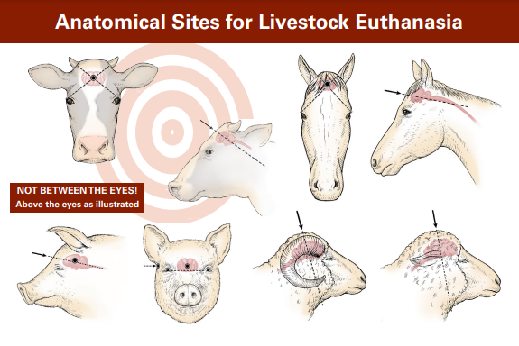
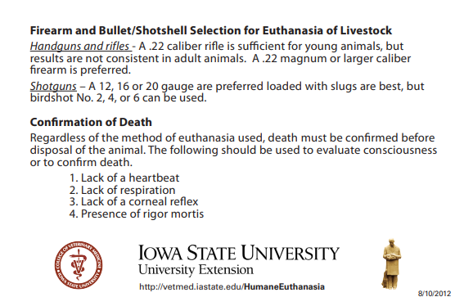
  - Unacceptable methods
    - Applying blunt force to the head (i.e., large hammer or smashing against the ground) in all animals except suckling piglets and some poultry
    - Injecting any chemical substance that is not labeled for use as a euthanasia agent
    - Injecting air into a vein
    - Electrocuting using a 120- or 220-volt electrical cord
    - Exsanguination without another method prior to use
    - Many others
- Confirmation of death
  - Majority of animals seen are mammals so same criteria apply as with humans, but varying anatomy can make some methods of confirmation more difficult
  - Absence of a heartbeat
    - Confirmed by use of a stethoscope placed under the left elbow
      - Since involuntary movements including leg twitches/kicks can occur after any euthanasia or depopulation method, approach the animal from their back to avoid danger zones
    - Pulses are hard to feel – not an appropriate way to confirm death
  - Lack of respirations
    - Visual – movement of the chest
      - Agonal breaths can occur after death so need to observe until all breathing stops for 5 minutes
      - Respiration rates may be very erratic or absent in unconscious animals – be cautious if using this as the sole means of death confirmation
  - Lack of a corneal reflex
    - The animal does not blink when the eyeball is touched
    - Pupil will be dilated, and cornea will be tacky to the touch
Animal Relocation
Once animals have been freed from whatever predicament they managed to get into, they may need to be transported to another site for medical care or for temporary housing until they can be hauled to their original destination or home.
- Recommend using a pickup truck and livestock trailer (not a semitrailer) if possible and species specific
  - Have list with potential haulers (reference County Contact List)
  - Do not leave just one animal at the scene or on the trailer by themself if possible
    - Most are herd animals and are less stressed when they have a buddy
  - Do not load on concrete/pavement since they can slip and cause more injuries
    - If no other choice, cover the loading area with dirt/sand
  - Many animals will not cross lines on pavement (cannot judge depth and distance) so cover with sand or dirt
  - Have the driver be extra cautious while driving since animals will be scared and may be injured
- Relocation facilities criteria
  - Pre-identified on the County Contact List per species that they can house
  - Have species appropriate handling equipment available so the animals can be safely restrained and treated
  - Have a quarantine/isolation area identified to maintain biosecurity
  - Have owners/managers that are knowledgeable on normal behavior, illness/injury, feeding requirements, and ability to handle basic medical treatments for the relocated species
  - Have veterinary services available within a reasonable distance and time frame
  - Potential facilities may be fairgrounds, livestock show arenas, auction markets, boarding facilities, privately owned farms, large animal veterinary hospitals, etc.
Mortality Management
Despite our best efforts at planning and training, some animals will not survive either the initial incident or will need to be euthanized to prevent further suffering. Carcass/mortality management is another important aspect of animal response.
- Manage carcasses as soon as possible (do not leave on the side of the road for longer than necessary)
  - Per NC GS 106-403, disposal needs to occur within “24 hours after knowledge of the death of the domesticated animals”
  - Public perception is critical on how well an incident was handled
- Recognize scene sensitivity
  - Use visual barriers to limit public and media viewing
  - Keep carcasses covered or hidden until they can be removed from the scene
  - Maintain carcass integrity as much as possible during extrication, loading, and transportation
- Transportation of carcasses
  - Use the appropriate equipment to load (e.g., heavy equipment, tarps, wide straps)
  - Maintain biosecurity in transport vehicles so roadways are not contaminated (leak proof containers, lined with heavy plastic, etc.)
- Know available options including afterhours and weekends
  - Should be on County Contact List
  - Possible options include, but not limited to, landfills, composting, rendering, burial, incineration
    - Know local ordinances on which methods are acceptable
  - Diagnostic laboratories will take care of disposal if further testing is warranted and most have after-hours drop-off options
    - This is not for routine disposal needs
Debriefing
- Highly recommended when dealing with accidents involving pain, suffering, and death in humans and animals
  - Many humans have strong emotional ties to animals, and it can be difficult to witness or be part of actions to alleviate their suffering
- Ground rules
  - Preferably scheduled within 24hrs of the incident or as soon as possible
  - Only invite those that were directly involved
  - Best if facilitated by a neutral party (e.g., counselor, clergy, trained medical personnel)
  - All discussions remain confidential
  - Non-threatening environment – ok to disagree but not to assign blame
    - Egos and rank are checked at the door
  - Focus on what individuals did well
  - Identify areas for improvement
  - No interruptions or outside conversations
  - All participants should be allowed to express their feelings, emotions, and thoughts
- Depending on scope, scale, and lessons learned, create an After-Action Report to determine what went well, what should be done differently next time, and what additional trainings or resources are needed.

Appendix A
NC Large Animal Response Volunteer Organizations

Contact information for trained responders in the state is provided alphabetically by county within NC Emergency Management Branches. They are listed by county to better coordinate with local response, but majority of organizations travel outside their home county.

*** All organizations are comprised of volunteers that may have other commitments but will assist if able*** If they are unable to assist or are too far away for a favorable outcome, they may know of other teams that are available or give guidance over the phone.

- Eastern Branch
  - Brunswick County
    - Grissettown Longwood Fire Rescue Department
      - Brunswick and surrounding counties – will travel farther as needed
      - Chief Tal Grissett
        - 910-279-1377
        - Station31@atmc.net or talgrissett@yahoo.com
      - Asst. Chief Richard Teague, Jr
        - 910-279-6994
        - Richardteague01@yahoo.com
      - Station 31
        - 910-287-3030
        - Station31@atmc.net
  - Pender County
    - Pender County Animal Shelter
      - 910-259-1484
      - Can assist as needed depending on availability and location, through normal government mutual aid request
    - Horton’s Rehab Ranch, Inc
      - Jewell Horton – cell: 910-540-2237
      - hortonsrehabranch@gmail.com
- Central Branch
  - Forsyth County
    - Piedmont Emergency Animal Response Team (PEART)
      - Service Area includes Alamance, Caswell, Davidson, Davie, Durham, Forsyth, Guilford, Orange, Person, Randolph, Rockingham, Surrey, Stokes, and Yadkin Counties
      - https://www.facebook.com/PiedmontEmergencyAnimalResponseTeam
      - Call 911 if in the Piedmont region of NC
      - Scottie Emerson (PEART Operations Officer)
        - Cell: (336) 403-9932
        - rsqguru@aol.com
      - Michelle Brock (PEART Coordinator)
        - Winston-Salem/Forsyth County Emergency Management
        - Office: (336) 917-7074
        - michelleb@cityofws.org
  - Moore County
    - 4Hooves Large Animal Services LLC (4HLAS)
      - Can travel throughout the state depending on personnel availability and incident circumstances. Have a satellite response unit in Johnston County.
      - https://4hoovessmart.com
      - Justin and Tori McLeod, Owners
        - Call or text (910) 494-8210 or (919) 201-6789
      - Email NC4HLAS@gmail.com (do NOT use email for an emergency)
- Western Branch
  - Buncombe County
    - Fairview Fire Department
      - Willing to respond in Western NC, farther as needed depending on incident
      - Main station: 828-628-2001
      - Scott Jones, Chief
        - 828-712-9713
        - scottj@fairviewfirerescue.com
  - Cabarrus County
    - Georgeville Fire Department
      - Have trained personnel and equipment, all volunteers so not always staffed, located in Concord but willing to assist regionally
      - Contact Cabarrus County Communications Center: 704-920-3000
      - Direct line to station: 704-782-3370
      - Jamie Blackwelder, Assistant Fire Chief: jblackwelder@georgevillevfd.com
  - Henderson County
    - Etowah Horseshoe Fire and Rescue
      - Willing to travel, 24ft trailer outfitted for response
      - Direct line to station: 828-891-3111
      - Chief Mike Huggins: 828-691-1683 (cell)
        - chief@etowahhorseshoefire.com

Appendix B
Organizations Offering Animal Rescue/Response Courses

*This is not an all-inclusive list and other organizations not listed may also offer large animal response trainings. Organizations are listed in alphabetical order only.

4Hooves Large Animal Services LLC (4HLAS): https://4hoovessmart.com/welcome

Animal Search and Rescue (ASAR): https://asartraining.com

Code 3 Associates: https://code3associates.org

Piedmont Animal Emergency Response Team (PEART): https://www.cityofws.org/2804/Piedmont-Emergency-Animal-Response-Team

Appendix C County Animal Emergency Response Resources

NAME | CONTACT PERSON | PHONE NUMBER
NCDA&CS Veterinary Division | Dr. Martin -State Vet  Dr. Harris – Livestock  Dr. Mansell – Poultry | (919) 707-3250
Local Livestock Veterinarian(s)
Local Small Animal Veterinarian(s)/ Emergency Clinic
Local wildlife contact (NCWRC, USFWS*)
County Animal Services
Local Livestock Extension Agent
Local Cattle Producer/ Cattleman’s Association
Local Horse Person or Association
Local Pork Producer/ NC Pork Council
Local Poultry Producer/ Company
Local Sheep Producer/ NC Sheep Producer’s Association
Local Goat Producer
Local Llama/Alpaca Expert
Local Beekeeper’s Assn/Apiarist
Exotics Contact (i.e., venomous snakes, big cats)
Local Livestock Transporter
Livestock Holding Facilities
Portable Corrals/Panels
Livestock Disposal Facility (landfill, crematory, etc.)
Deceased Livestock Removal
Tow Truck (with crane capabilities if needed)
Other Resources
* NC Wildlife Resources Commission – native wildlife, US Fisheries and Wildlife Services – non-native wildlife

Appendix D
Animal Transport Incident Assessment
Responding law enforcement _________________________ Department______________________
Phone:______________________________ Email:________________________________________
Location of incident_________________________________________________________________
Date/Time of Incident _______________________________________________________________
Driver’s name: ______________ | Age group/size:
- Functional | - Young/small
- Non-functional | - Intermediate/medium
Trailer Type: | - Mature/large
- Bumper pull trailer | Quantity
- Gooseneck trailer | - Actual if known __________
- Pickup with carrier in bed | - Estimate if unknown ________
- Semitrailer (straight load) | Destination
- Semitrailer (potbelly) | - Farm
Vehicle condition: | - Slaughter Plant
- Operable | - Auction Market
- Non-operable | - Feedlot
Trailer accident result: | - Other
- Upright | Scene Security Status
- On-side left right (circle one) | - Contained
Accident site: | # Tied __________
- Urban | # Loose __________
- Rural | - Escaped
- On road | Health Status
- Shoulder | - Uninjured __________
- Ditch | - Injured ___________
- Other | - Dead ____________
Animal Type: | - Unknown __________
- Cattle | Extrication
- Horses | - Yes
- Pigs | - No
- Poultry | Support Required (circle requests)
- Sheep or goats (circle one) | - Personnel
- Llama or alpaca (circle one) | Veterinarian
- Other_________________ | County Extension Agent
 | Technical Large Animal Rescue Team
Emergency Contact _____________________ | - Equipment
Comments: | Fencing
 | Gates
 | Lighting
 | Tow Truck

Animal Emergency Incident Assessment
(Not Involving Transport)

Responding agencies/organizations: _______________________________________________________
Phone: ___________________________________Email: ______________________________________
Incident location: ______________________________________________________________________
Date/Time of Incident: __________________________________________________________________
Owner/Responsible party: __________________________ Phone: ______________________________
Owner: Available Unavailable | Health Status of Animal(s):
Human Injury | - Uninjured
- Yes – extent: | - Injured (circle one): Minor Severe
- No | - Dead
Species Involved: | - Unknown
- Cattle | Accessible by vehicles:
- Horses | - Yes
- Pigs | - No
- Poultry | Why?
- Sheep or goats (circle one) | Requires Immediate Medical Care
- Llama or alpaca (circle one) | - Yes
- Other _________________ | - No
Number of Animals Affected: | Support Required (circle and list type)
Type of Incident | - Personnel
- Loose Livestock | Animal Services/Control Officer
Near roads: Yes No | LEO: Local State Wildlife
- Water Involvement (circle all that apply) | Veterinarian
Swift water Pool/Ponds | County Extension Agent
Ice Mud | Technical Large Animal Response Team
- Fire (circle one) | Advice/Guidance via phone
Wildfire Structure | Trained personnel for incident type
- Confined Space Trench | Other:
Structural Collapse (circle one) | - Equipment:
CSR Permit in Place? Yes No | TLAER specific: list
- Entrapment | Fencing
Type: | Gates
- Down for medical/unknown reason | Lighting
Abandonment/neglect/cruelty case | Heavy Equipment
- Hazmat incident requiring decon | Transport: Truck Trailer Both
ERG/SDS Info/Substance: | Appropriate PPE
- Other: | Other:
Age/size: (circle all that apply) | Additional Comments:
Young/small
Intermediate/medium
Mature/large
CSR: Confined Space Rescue LEO: Law Enforcement Officer ERG: Emergency Response Guidebook
SDS: Safety Data Sheet TLAER: Technical Large Animal Emergency Response PPE: Personal Protective Equipment
Appendix E
Dispatcher Decision Tree

Appendix F
Notification Process
Appendix G
Species Specific Information
Cattle (bovine)
- Basic terminology
  - Cow – female
  - Bull – intact male
  - Calves – young cattle
  - Heifer – cow that has not calved
  - Steer – castrated male cattle
  - Cattle – group of bovines of mixed genders
- Identification
  - Ear tags are the most common
    - Farm tags – handwritten or printed, only used for that farm’s records
    - Official United States Department of Agriculture (USDA) ear tags – small metal clips, Radio Frequency Identification (RFID) tags, 840 tags – have US shield and “unlawful to remove” on it and an 8–9-digit code that can be used to trace to farm of origin
  - Ear tattoos – for breed registration so will need to know the cattle breed for traceability
  - Brands – farm specific and used to trace to farm of origin, can be freeze or hot branded
- Basic handling
  - Herd animals, like to stay in a group and will go through people to make it happen, especially when stressed
  - Use flight zones to move
    - Beef breeds tend to have larger flight zones than dairy cattle (some dairy and most show animals have no flight zone)
  - Can swing hind leg in a wide arc and reach farther than expected (cow kick)
  - Will charge if agitated or stressed – watch body language/posture
    - Ears erect, head low to the ground and staring, pawing ground – they may be ready to charge
  - If stressed and pushed, some cattle can and will jump over cattle panels
  - Still use caution if down. If stressed enough and depending on their condition, they may jump up and chase. If sternal, can swing head and cause severe injury. If lateral, can injure with head and hooves. See “Animal Danger Zones” for more information.
- Extrication specific to cattle
  - Cattle get up with rear legs first and then front end
    - Be careful near head if trying to get up since hind end will push them forward
  - Cattle are prone to bloat if on their sides or back for even a short length of time. Get them standing or propped up on their chest as soon as possible so they can eructate (expel rumen/stomach gases) to prevent fatal bloat conditions.
  - Be cognizant of udders on milking cows (dairy or beef) and testicles on males when placing straps/webbing
- Euthanasia
  - See Euthanasia Section for other options
    - Gunshot or penetrating captive bolt information specific to cattle
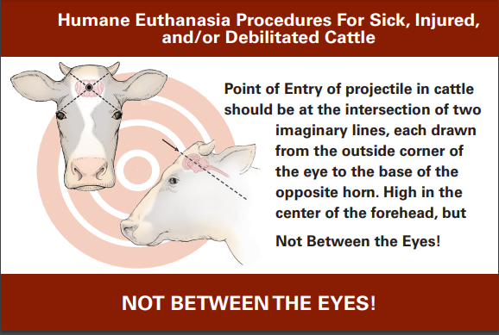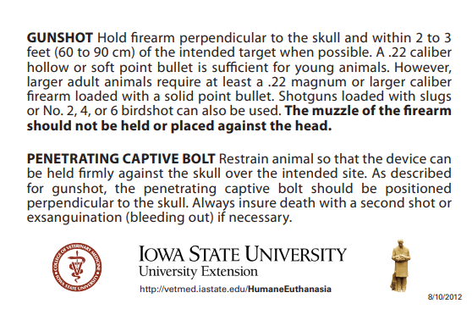

Equines (horses, donkeys, zebras)
- Basic terminology
  - Mare – female horse
  - Stallion – intact male horse
  - Gelding – castrated male horse
  - Foal – young horse (any sex)
  - Filly – young female horse
  - Colt – young male horse
  - Jenny – female donkey
  - Jack – male donkey
  - Mule – offspring of a male donkey and a female horse
- Identification
  - If traveling, legally there should be a Coggins Form in the towing vehicle showing that the animal has tested negative for the disease called Equine Infectious Anemia in the previous 12 months
    - This should have animal’s markings drawn or pictures of the horse, name of the animal, owner’s information, and other forms of permanent identification listed (e.g., brand, scars, microchip number)
  - If traveling across state line, a Certificate of Veterinary Inspection (CVI)/Health Certificate should be available which will have origination, destination, and owner’s information
  - Some horses have been microchipped
    - Use a universal scanner (not all chips use the same frequency)
    - Should have been placed halfway between the poll (just behind their ears) and the withers (highest point of their back at base of neck) on the left side and an inch down from the top of the neck but microchips can migrate nor are placed in the standard location so check a wide area on both sides of the neck
  - Branding (freeze or hot iron) – used by specific ranches for farm of origin or breed registries (e.g., BLM mustangs, some warmbloods)
  - Lip tattoos – Required by certain racing commissions and can be seen with any horse that has been on the track (e.g., Thoroughbreds, Quarter Horses, Standardbreds)
- Basic Handling
  - Most are halter broke
    - Lead from the animal’s left side (use the human’s right hand)
    - Do not hold directly onto the halter (no time for you to get to a safe place if they react) but do not give them feet of rope (no control) – there is a happy medium
    - See Animal Behavior section on makeshift halters and quick release knots
    - Use a quick release knot or snap anytime a horse is tied – not all horses will stand tied especially when stressed
    - Only tie to solid objects that cannot be moved by a startled 1200lb animal
  - If not halter broke or unable to catch, use flight zones just like any other livestock species
- Extrication
  - Humans often have a stronger attachment to horses than other livestock and will put themselves at greater risk to save them
  - Document heavily especially with any injuries or mortality since they can be quite expensive and may have insurance (may require a necropsy so confirm prior to disposal)
  - Due to large size, sensitive to being down for long periods of time (collapsed lung, severe muscle damage resulting in kidney failure)
  - Although the animal may appear sedate/asleep, they can/will react violently at any moment and when least expected
    - Always stay out of danger zones
      - Even if down on their side, they can roll over faster than expected
      - Do not trust even if sedated or under general anesthesia. More people are injured by horses under chemical restraint because they think they are safe.
      - Use arm extensions and ropes whenever possible to keep you in the safe zones
  - Equines get up front end first so need lots of space to throw front legs out in front of them
    - Can get up extremely quickly and react before all legs are on the ground – keep a safe distance from head, neck, and legs
    - If trying to assist with standing, can place front legs out to help encourage them to get up (use ropes and extensions to place limbs)
- Euthanasia
  - See Euthanasia Section for all options
    - Gunshot or penetrating captive bolt information specific to horses
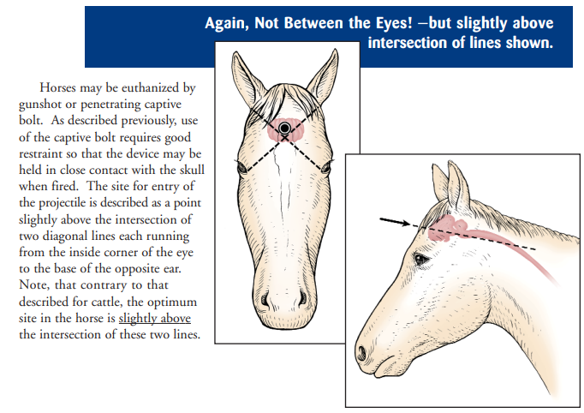

Goats/sheep
- Basic terminology
  - Goats (caprine) (tails point up unless they are extremely cold or sick)
    - Doe or nanny – female
    - Buck or billy – male
    - Wether – castrated male
    - Kid - young
  - Sheep (ovine) (tails point down)
    - Ewe – female
    - Ram – male
    - Wether – castrated male
    - Lamb – sheep less than a year old
    - Wool and hair varieties exist
- Identification
  - May not have official identification so use description (size, color, species, sex, etc.)
  - Farm Tags - handwritten or printed, only used for that farm’s records
  - Official ear tags – most common, required when sold, US shield, and unique number that traces to the farm of origin
  - Tattoo – registered animals only, will need to know breed to find owner, most common in both ears but can be on the caudal tail fold of Lamancha goats
- Basic handling
  - Try not to grab sheep by the wool if possible (very painful and can separate skin from underlying tissue)
  - Horns make great handles but only if tightly adhered to their skull
    - Do not use in young animals – will pull off horn capsule and have a bloody mess
  - Some are halter broke, but majority are not
  - May follow a bucket of grain (or something that sounds like it)
  - Sheep tend to flock together and can be easier to herd than goats
  - Trained dogs can be an asset for herding but need to be trained to work with sheep and goats
- Extrication specific to sheep and goats
  - Similar to cattle, can be severely compromised by bloat if down on their side or back for even short periods of time
  - Extremely sensitive to stress
- Euthanasia
  - See Euthanasia Section for other options
    - Gunshot or penetrating captive bolt information specific to sheet and goats
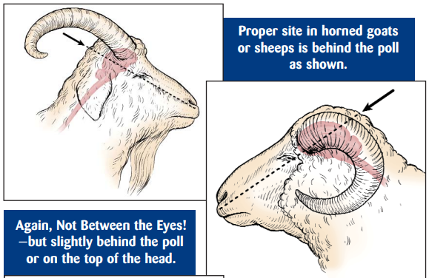

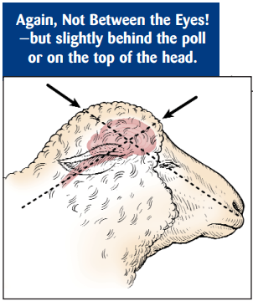
Swine (porcine)
- Basic terminology
  - Sow – mature female that has farrowed
  - Gilt – young female
  - Boar – intact mature male
  - Barrow – young, castrated male
  - Hog – mature swine (usually >120 pounds)
  - Pig or piglet – young swine (usually <120 pounds)
  - Farrow – to give birth
- Identification
  - In NC, all swine that leave their property are required to have some form of official identification even if going directly to slaughter
    - Distinguishes between domestic and feral swine
    - Ear tag, tattoo (ear, inner flank, or slap tattoo), ear notches
      - Animal’s right ear is litter number and left ear is animal number (reference guide for ear notching)
  - If not officially identified, can describe by physical characteristics such as color, size, erect or floppy ears, etc.
- Basic handling
  - They are extremely vocal and loud – wear ear plugs when working with them
    - Not necessarily an indicator of pain or stress
  - Use sorting boards (or makeshift boards such as plywood, backboards, etc.) to move and corral loose animals
  - Make sure bottom portable corrals are solid or staked down since swine will root under and pick up objects heavier than expected
    - Can flip tube/pipe cattle panels over so the top is flat on the ground therefore less room for them to root under
  - Be very careful especially with full sized animals – can be very aggressive and dangerous
- Extrication specific to swine
  - Have good containment to another trailer or holding pen in place before opening a trailer since they are good at escaping and difficult to catch once loose
    - Fast and few grab points – can catch by a leg
  - Pig snares work best for restraint but can be challenging to apply
- Euthanasia per AVMA Guidelines on Euthanasia
  - Swine over 70lbs – gunshot, penetrating captive bolt, anesthetic overdose
  - Swine under 70lbs – gunshot, penetrating or non-penetrating captive bolt, anesthetic overdose
  - Suckling pig – manually applied blunt force trauma is an approved method
    - Not aesthetically pleasing – alternative methods may be recommended depending on situation

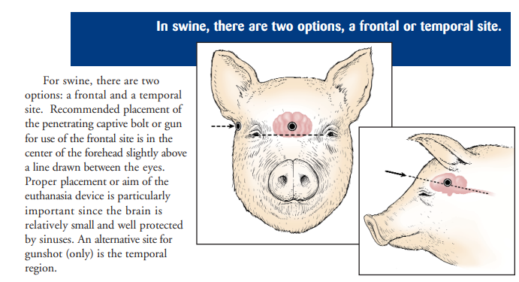

Poultry (chickens, turkeys, commercial waterfowl)
- Basic terminology
  - Chickens
    - Chick – newly hatched or very young chicken
    - Broiler – 6-13 week of age meat bird
    - Pullet – female less than a year of age
    - Hen – female over a year of age
    - Cockerel – male under a year of age
    - Rooster – male over a year of age
  - Ducks
    - Drake – adult male
    - Duck – adult female
    - Duckling – young duck
  - Geese
    - Gander – adult male
    - Goose – adult female
    - Gosling – young goose
  - Ratites – large, flightless birds that lack a keel on the sternum for flight muscles to anchor
    - Examples include ostrich, emu, rhea, cassowary, and kiwi
  - Turkeys
    - Poult – young domestic turkey
    - Hen – adult female
    - Tom – adult male
- Identification
  - Limited individual identifications (some may have leg bands)
- Basic handling
  - May be able to grab by approaching the birds slowly and quietly
    - Easier if several people can work together
  - Can use a large fishing net
    - Be prepared to carefully untangle wings, head, and legs from netting
  - Once caught, hold wings against body to prevent flapping and injury
  - Use extreme caution if handling large tom turkey and ratites - can be extremely dangerous
- Extrication specific to poultry
  - Crush injuries and suffocation are common especially for those lower in the load
- Approved euthanasia/depopulation methods
  - Euthanasia - see AVMA Euthanasia Guidelines for additional information
    - Gas inhalation
      - Many options but CO₂ is the most common
      - Death needs to be verified because they may appear dead but can regain consciousness if exposure time and/or concentration was not sufficient
    - Cervical dislocation – should only be performed by experienced personnel
    - Decapitation
    - Manually applied blunt force trauma
      - Turkeys or broiler breeders that are too large for cervical dislocation
      - Fatigue is a problem with a large number of birds – use another method is possible
    - Gunshot – used for free ranging poultry and ratites when unable to be caught/restrained
    - Captive bolt (penetrating and non-penetrating) – device needs to be designed and configured for species and bird size with appropriate restraint
    - Injectable agents – disposal concerns
  - Depopulation – see AVMA Guidelines for Depopulation of Animals for more information
    - Necessary when a large number of birds are affected, and euthanasia methods would take too long to relieve suffering
      - Examples include natural disasters such as flooding of a house, tornado or other structural damage and not safe to enter, disease
      - NCDA&CS Poultry Division should be contacted for any large disaster incident involving depopulation
Non-traditional livestock species/exotics
- Camelids (llamas and alpacas are most common)
  - Basic terminology
    - Llama – larger (260-440lbs and 3.3-4.2ft at the withers/top of the shoulders), banana shaped ears and high tail set
    - Alpaca – smaller (130-180lbs and 2.7-3.2ft at the withers), shorter spear-shaped ears, lower tail set
    - Stud – intact male
    - Dam – intact female
    - Cria – young
    - Gelding – castrated male
  - Identification
    - Microchipping is very common (required for registered animals)
      - Typically placed at the base of the left ear but check entire head and neck since they can migrate
    - Color, pattern, and fiber type (huacaya or suri)
  - Basic handling/behavior
    - Spitting – will bring up stomach contents and spray it when stressed or agitated
      - Will hear a gurgling sound as a warning as they are bringing up contents
      - Will spray like a sprinkler and not a spit ball
      - Very malodorous
    - Humming – soft sound that is a sign of stress
    - Cushing - stress response where they lay down with feet under them and refuse to move
      - Do NOT assume they are severely injured if they are sitting up but refusing to get up and move
    - Can kick quickly with hind legs and are very accurate
    - Since very little is taught/known about camelids, it may be difficult to find a veterinarian that is comfortable or knowledgeable about treating them
      - Some resources to assist in identifying a veterinarian willing to treat camelids are NC State University College of Veterinary Medicine, NC Cooperative Extension livestock agents, zoos, and other large animal/livestock veterinarians
  - Approved euthanasia methods
    - Anesthetic overdose
      - Can be difficult to gain veinous access due to neck length and musculature
    - Gunshot or penetrating captive bolt
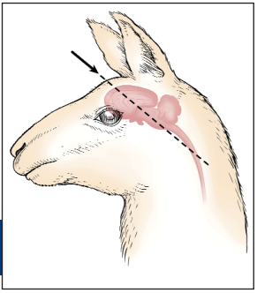

- Honeybees
  - The North Carolina State Beekeepers Association can be a valuable resource when dealing with honeybees
  - Basic terminology
    - Apiary – colonies, hives, and other equipment assembled in one location for beekeeping operations (aka bee yard)
    - Beehive – a box or container with movable frames used for housing a colony of bees
    - Bee veil – cloth or form of hat usually made of netting to protect the human’s head and neck from stings
    - Drone – male honeybee
    - Queen – female bee with a fully developed reproductive system, larger and longer than worker bees, typically only 1 per colony
    - Worker bee – female bee whose reproductive organs are undeveloped, do the work in the colony except for laying fertile eggs
  - Vehicular accident with hives
    - Have signboards telling motorists to keep windows rolled up at least ¼ mile before and at least ¼ after the accident site
      - Have responders wear protective clothing with no gaps between protective layers to prevent stings Lighter colors (white) are preferred
    - Try to save the bees if at all possible since their pollination services are required for certain crops
      - If necessary to depopulate, can use firefighting foam
- Captive deer/farmed wildlife, bison, big cats/zoo animals
  - Contact US Fish and Wildlife Services listed on county contact sheet
  - In NC, contact the NC Wildlife Resources Commission. For severely injured white-tailed deer, contact the NC Wildlife Helpline at 866-318-2401 (Mon-Fri. 8 am- 5 pm) or the Wildlife Enforcement Division at 800-662-7137 if outside of business hours.

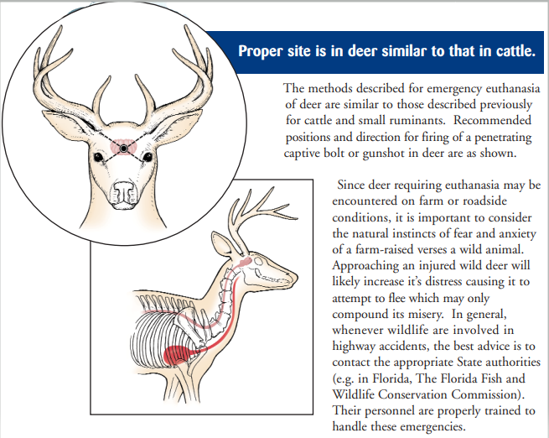

Appendix H
Normal Vitals of Common Animal Species

May not be able to assess and can be elevated from stress.
Species | Temperature (Fahrenheit) | Pulse (beats/min) | Respirations (breaths/min)
Horses | 99.0-101.0 | 28-40 | 8-16
Cattle | 100.0-102.5 | 40-100 | 10-30
Swine | 101.5-103.5 | 60-100 | 15-20
Sheep/goats | 101.0-104.0 | 70-90 | 12-20
Chickens | 105.0-109.4 | 250-300 | 12-37
Dog | 100.5-102.5 | 60-120 | 15-30
Cat | 99.0-102.5 | 140-220 | 20-30

Appendix I
Additional Resources

Additional Resources (websites, books, etc.)
- Technical Large Animal Emergency Rescue, Rebecca Gimenez, Tomas Gimenez, Kimberly Anne May, 2008
- Rebecca Gimenez Husted playlist under Surefoot Equine YouTube videos
- Facebook group: Technical Large Animal Emergency Rescue
- www.4hoovessmart.com
- https://flsart.org/resource/TLAER/TLAER.pdf
- www.thenasaaep.com – additional information on specific subjects under the resources tab
Resources:
Just-in-Time training for responders during animal health emergencies, The Center for Food Security & Public Health: https://www.cfsph.iastate.edu/emergency-response/just-in-time-training/
Procedures for the Humane Euthanasia of Sick, Injured, and/or Debilitated Livestock: http://neacha.org/resources/Humane.livestock.Euthanasia.pdf

Appendix J
Mental Health Assistance Resources

This list is not all inclusive nor are all resources suited for every individual. If a resource is not offering the level of assistance needed, please contact others on this list or from other sources.

Suicide & Crisis Line – Dial 988
- www.988lifeline.org

Farmer/Producer Hotline
- NC Farm & Ranch Assistance Network
- https://ncfarmstress.org/
- Crisis lines
  - NC Farm Help Line 1-844-325-3276
- Self-help resources
- Support groups
- Programs and services
- Farm finance and management
- Training
- Media
- Community resources
- Rural Advancement Foundation International-USA
- www.rafiusa.org
- Farm Advocacy Program
  - Farmer’s Crisis Hotline 866-586-6746
- Cooperative Extension – assistance listed by county
  - https://eod.ces.ncsu.edu/learning-opportunities/mental-health-and-crisis-solutions-in-north-carolina/

First Responders
- NC First Responder Peer Support Team
  - www.ncffps.org
- Emergency Contacts
- Peer Support Resources
- The Code Green Campaign
  - www.codegreencampaign.org
  - Resource database
  - Education and public speaking
  - Consulting
  - Share your story
  - Submit a memorial for those who were lost by suicide

Pet Loss and Grief Support Hotlines
- Florida Animal Health Foundation's Pet Grief Support Hotline
  - 800-798-6196
  - University of Florida veterinary student volunteers will return calls between 7-9pm daily
- Ohio State University College of Veterinary Medicine
  - 614-292-1823
  - Monday-Friday 6:30pm-9:30pm, Saturday-Sunday 10am-4pm
  - Hotline coverage is dependent on volunteer availability
- Pet Loss Support Hotline
  - College of Veterinary Medicine, Cornell University
  - 607-253-3932
  - Tuesday, Wednesday, and Thursday 6-9pm EST
- Iams Pet Loss Support Center and Hotline
  - 888-332-7738
  - Monday-Friday 8am-5pm
- Pet Loss Support Program Hotline
  - American Society for the Prevention of Cruelty to Animals (ASPCA)
  - 877-474-3310
- C.A.R.E. Helpline
  - College of Veterinary Medicine at the University of Illinois
  - 877-394-CARE (2273)
  - Staffed by veterinary students who have received training by professional grief counselors
- Pet Loss Partnership
  - Washington State University, College of Veterinary Medicine
  - 509-335-5704
  - Monday, Wednesday, and Thursday 6:30-0pm, Saturday 1-3pm Pacific Time
  - Messages can be left 24 hours and will be returned as soon as possible
- The Virginia-Maryland Regional College of Veterinary Medicine
  - 540-231-8038
  - Tuesday and Thursday 6-0pm EST
- Iowa State University Toll-free Pet Loss Support Hotline
  - 888-478-7574
  - September -April: 7 days a week from 6-9pm CST
  - May-August: Monday, Wednesday, and Friday 6-9pm CST
- University of Florida Pet Loss Support Hotline
  - 352-392-4700, ext. 4080
  - Call will be returned 7-9pm EST

Appendix K
Acronyms

ADA: Americans with Disabilities Act
AERWG: Animal Emergency Response Working Group (
CART: County Animal Response Team
CVI: Certificate of Veterinary Inspection EM: Emergency Management
FEMA: Federal Emergency Management Agency
4HLAS: 4Hooves Large Animal Service
DHS: Department of Homeland Security
IC: Incident Commander ICE: In Case of Emergency
ICS: Incident Command System
MOU/MOA: Memorandum of Understanding/ Memorandum of Agreement
NC ART: North Carolina Animal Response Team
NCCE: North Carolina Cooperative Extension
NCDA&CS: North Carolina Department of Agriculture and Consumer Services
NCDPS: North Carolina Department of Public Safety
NCWRC: North Carolina Wildlife Resource Commission
NIMS: National Incident Management System
PEART: Piedmont Emergency Animal Response Team
PETS Act: Pets Evacuation and Transportation Standards Act
PIO: Public Information Officer
PFD: Personal Flotation Device
PPE: Personal Protective Equipment
RFID: Radio Frequency Identification
SCBA: Self Contained Breathing Apparatus
TLAER: Technical Large Animal Emergency Response
USDA: United States Department of Agriculture
USFWS: United States Fish and Wildlife Services

Appendix L
Manual Contributors

Amanda Winans – 24-Hour Watch Manager, NCDPS Emergency Management
Anna Allen, DVM – Southeastern Region Emergency Programs Veterinarian, NCDA&CS Emergency Programs Division
Anna McRay – Assistant Director, New Hanover County Emergency Management
April Bowman – Agriculture Extension Agent, Forsyth County NC Cooperative Extension, PEART volunteer
Bryan Blinson - Executive Director, NC Cattlemen’s Association
Bryan Harkey – Field Operations Manager, Charlotte-Mecklenburg Police Department, Animal Care and Control Division
Carol Woodlief, DVM – Veterinarian, NCDA&CS Veterinary Division/Livestock
Crystal Cook Marshall, PhD – Director of AgrAbility Partnership, Agromedicine Coordinator, Cooperative Extension at NC A&T State University
Daniel Webb –Emergency Services Coordinator, Edgecombe County
Donald Hopkins – Apiary Inspector, NCDA&CS Plant Industry Division
Ivey Smith, DVM – Veterinarian, Greene County Animal Welfare Board
Jay Royster – Radiological Emergency Preparedness Planner, NCDPS NC Emergency Management
Jennifer Federico, DVM – Director, Wake County Animal Services
Joel Wood – Area 9 Coordinator, NCDPS NC Emergency Management
Justin & Tori McLeod – Owners and operators of 4Hooves Large Animal Services LLC
Kate Marshall – Animal Protective Services, City of Southport
Kelly Emerson – PEART volunteer
Kelly Nilsson – EP Disaster Recovery Coordinator, NCDA&CS Emergency Programs Division
Marianne Bond – Captain, Durham Police Department
Mark Schell – Area 7 Coordinator, NCDPS NC Emergency Management
Madelyn Johnson – EMS Coordinator, Asheville-Buncombe Technical Community College
Michelle Bouchey, DVM – Northeastern Region Emergency Programs Veterinarian, NCDA&CS Emergency Programs Division
Michelle Brock – EM Coordinator, Planning & Training Officer, Winston-Salem/Forsyth County Emergency Management, PEART Coordinator
Michelle South – Livestock Area Agent, Avery County NC Cooperative Extension
Terri Richards – Former Radiological Emergency Preparedness Planner, NCDPS NC Emergency Management
Scottie Emerson – Operations Officer, PEART
Wendy Lane – Animal Health Technician, NCDA&CS Veterinary Division/Livestock

